Contemplative Service for Wednesday,
October 25, 2023

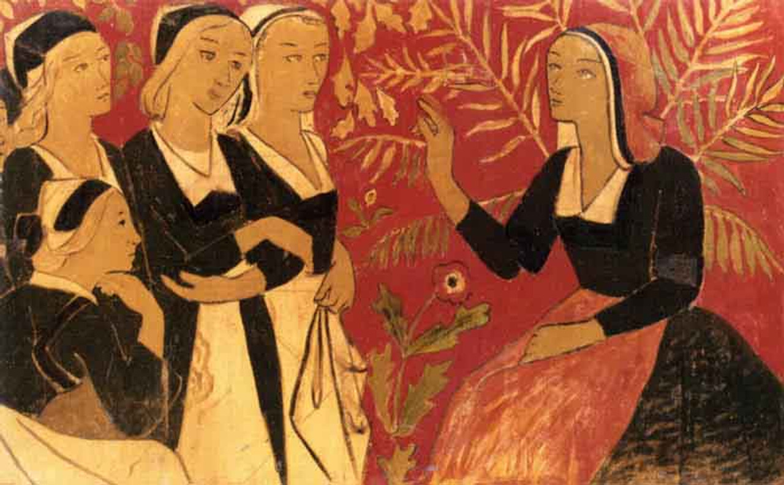
“The Storyteller” by Paul Serusier

First reading: Matthew 13: 34-35

All these things Jesus said to the crowds in stories; indeed, he said nothing to them without a story. This was to fulfill what was spoken by the prophet:
“I will open my mouth in tales and narratives;
I will utter what has been hidden since the foundation of the world.”

Music: “Wade in the Water” performed by The Spirituals Choir
https://www.youtube.com/watch?v=fxZ4H-gq_lc

Second reading: from Joel B. Green and Michael Pasquarello

The ‘revelation’ of God’s person is inextricably tied to the events in which God becomes different things, in a way that any person does; it is thus inextricably tied to narrative. This understanding of God is “storied.” Its content is embodied, lived.
*
The poet/prophet is a voice that shatters settled reality and evokes new possibility in the listening assembly.

Music: “Ringing Them Bells” performed by The Spirituals Choir
https://www.youtube.com/watch?v=M3wzlwUztd4

Time of Silent Contemplation

May the peace of our Guide and Friend go with you,
wherever the Spirit may send you.
May God guide you through the wilderness,
and protect you through the storm.
May God bring you home by a new road
and with a new story, rejoicing
at the wonders revealed to you.
May this renewed Love and Wholeness
bring you rejoicing
once again home.

—adapted from a Celtic blessing

Communal Blessing
Holy Word, when language fails and meanings fray, bring us again into your story.
We stutter, we are hoarse, we refuse to speak at all. Yet still: bring us into your poem, your song, your parable, your movement that exceeds any narrative we can imagine.

You are Word that speaks and Word that listens. Between us, this understanding—the story that we thought had broken into bits is reassembled to new light and meaning in You. Our raw edges take on new harmonies of revelation. Amen.

Music: “Something Inside So Strong” performed by The Spirituals Choir
https://www.youtube.com/watch?v=gkwzl8J5nWU

May you stretch your limbs and your spirit within your story
and find that it unites with many other stories.

