Contemplative Service for Wednesday,
October 4, 2023

Image by William Morris

First Reading: Psalm 115:4–8
Their idols are silver and gold,
the work of human hands.
They have mouths, but do not speak;
eyes, but do not see.
They have ears, but do not hear;
noses, but do not smell.
They have hands, but do not feel;
feet, but do not walk;
and they do not make a sound in their throat.
Those who make them become like them;
so do all who trust in them

Music: “Unknowing, Abide” by Darlene Franz
https://wisdomchant.bandcamp.com/track/unknowing-abide

Second Reading: from “Reflections on Idolatry” by Will McDavid

Implicit in the very question of idolatry lies the assumption that God will be reliably present in prayer, meditation, good deeds, etc; and will be reliably absent in selfishness, power, pursuit of fame, etc. Saying God is present in these doesn’t make them necessarily good; it’s only to say that in all things God works for good. Presenting overattachment to career versus attachment to Jesus as an either-or isn’t necessarily problematic, but it certainly shores up our tendency to make a sharp distinction between spiritual and unspiritual experience.
There’s more. Rowan Williams, in his quirky theology introduction Tokens of Trust, talks about recognizing God as a ‘seeing-through’ everyday experience to the richness underneath, which is necessarily spiritual. We think of the Eucharist, for example, in which one receives the bread and wine (physical elements) and simultaneously, in a sense through them, to experience the Divine. One definition of idolatry would be failing to “see through” to the reality behind something, but to stop with the thing itself.

Music: “Though I Sleep,” by Darlene Franz
https://wisdomchant.bandcamp.com/track/though-i-sleep

Time of Silent Contemplation

Late have I loved you,
Beauty so ancient and so new, late have I loved you!
Lo, you were within,
but I outside, seeking there for you,
and upon the shapely things you have made
I rushed headlong – I, misshapen.
You were with me, but I was not with you.
They held me back far from you,
those things which would have no being,
were they not in you.
You called, shouted, broke through my deafness;
you flared, blazed, banished my blindness;
you lavished your fragrance, I gasped; and now I pant for you;
I tasted you, and now I hunger and thirst;
you touched me, and I burned for your peace.
Amen.
—St. Augustine

Communal Blessing

Holy Steadfastness, when the ground seems to fall from beneath our feet, may we land in your solidity and wholeness. Bring us balance, for the world blurs before our eyes. We are wooed by our own fantasy of truth and think that we are holding it fast in our grasp. Unclench us, God, and place your own hand within the gap. There, may we feel our own pulse finding rhythm with yours.
Amen.

Music: “You Can Become All Flame: by Darlene Franz
https://wisdomchant.bandcamp.com/track/become-all-flame

Blessings of clarity and connection to truest meaning.

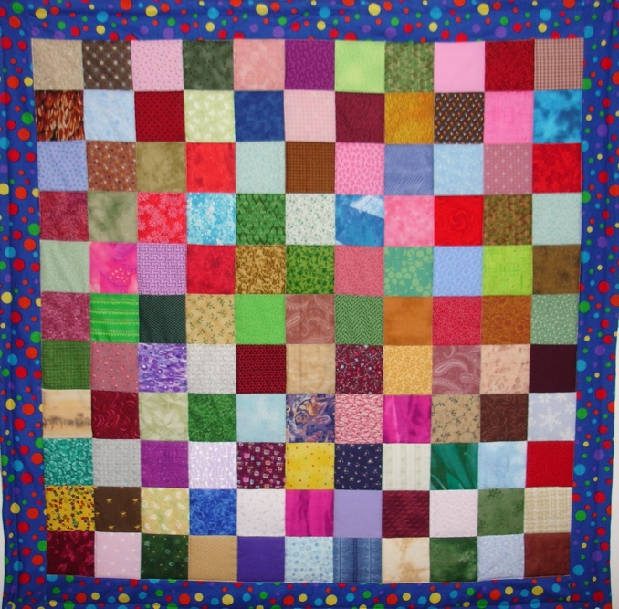

This coming Sunday!

Our sewing circle will be sharing their quilts this coming Sunday, so prepare to be dazzled by wonderful craftsmanship, color, and design. You may sponsor a quilt for a child at the Center for Early Intervention on Deafness or buy a quilt or other handmade items. Bring your checkbook!
*

We will be holding a special joint service on October 15th with The Good Table, a sister UCC church that is engaged in an inspiring project. Please stay tuned for details.

*

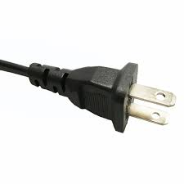

ELECTRIC VEHICLE SHOW
OCTOBER 15 AFTER CHURCH
In the Courtyard at the front of the sanctuary and in the driveway

Stay after church on October 15th for coffee and a snack and the Mercy & Justice Electric Vehicle Show. All participants are members of our church who will be available to discuss their vehicle(s). There will be cars, bikes, and an electric cart. Come and see how our congregation is moving away from fossil fuel pollution to electric vehicles.

Also, while you are at the show, pick up a handout about The Climate Center’s program to urge Governor Newsom to sign SB 253, SB 261, and AB 1167 into law. SB 253 and SB 261 are about corporate accountability for the climate and AB 1167 would require the owners of orphaned and idle wells to properly close them to protect neighboring communities and the climate. The handout will have a link to write to the governor urging his signature on these bills.

