Contemplative Service for Wednesday,
November 1, 2023

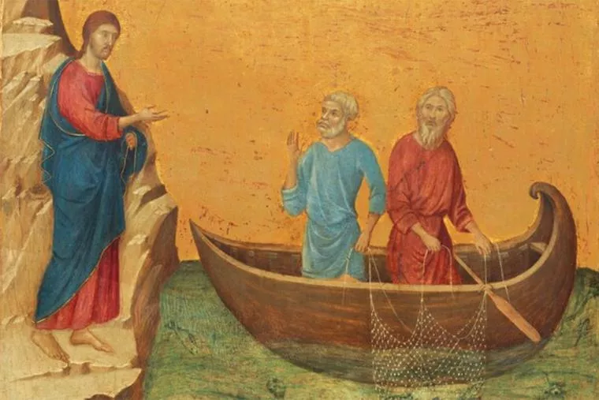

Painting by Duccio di Buoninsegna, 14th C.

First reading: Matthew 4: 18-22
As Jesus walked by the Sea of Galilee, he saw two brothers, Simon, who is called Peter, and Andrew his brother, casting a net into the sea—for they were fishers. And he said to them, “Follow me, and I will make you fishers of people.” Immediately they left their nets and followed him. As he went from there, he saw two other brothers, James son of Zebedee and his brother John, in the boat with their father Zebedee, mending their nets, and he called them. Immediately they left the boat and their father and followed him.

Music: “O Pastor Animarum” by Hildegard of Bingen
https://www.youtube.com/watch?v=taanHO13WXE

Second reading: from Dorothee Soelle, The Strength of the Weak

The most important virtue in this kind of religion is not obedience but solidarity, for solidarity asks that we change the image of God from that of a power-dispensing father to one of a liberating and unifying force, that we cease to be objects and become subjects involved in this process of change, that we learn cooperation rather than wait for things to come to us from on high. These are all elements of mystical piety.

Music: “Hymn Til Sankt Magnus,” Norwegian, circa 1200
https://www.youtube.com/watch?v=NWtDFySQqsg

Time of Silent Contemplation

My child, be patient and leave off
because God will not be torn
from the ground of your heart.
O deep treasure, how whilt thou be unearthed?

—from an anonymous letter, late Middle Ages, Germany

Communal Blessing

Sacred Beckoning, your call is irresistible but we are distractable followers. We get lost in grievance, tiredness, so many digressions from from the holy. But, look, the kindness of others, the pink in the cloud, a good meal shared, remind us that we can do what we were sure we could not do. We can follow in your way. By your love, amen.

Music: “Lux Aurumque” by Eric Whitacre
https://www.google.com/search?client=firefox-b-1-d&q=youtube+eric+whitacre+lux+aurumque#fpstate=ive&vld=cid:cc2bdf9a,vid:0j2JRcC6wBs,st:0

Love to feed you, faith to accompany you on your travels.

