Contemplative Service for Wednesday
January 18, 2023

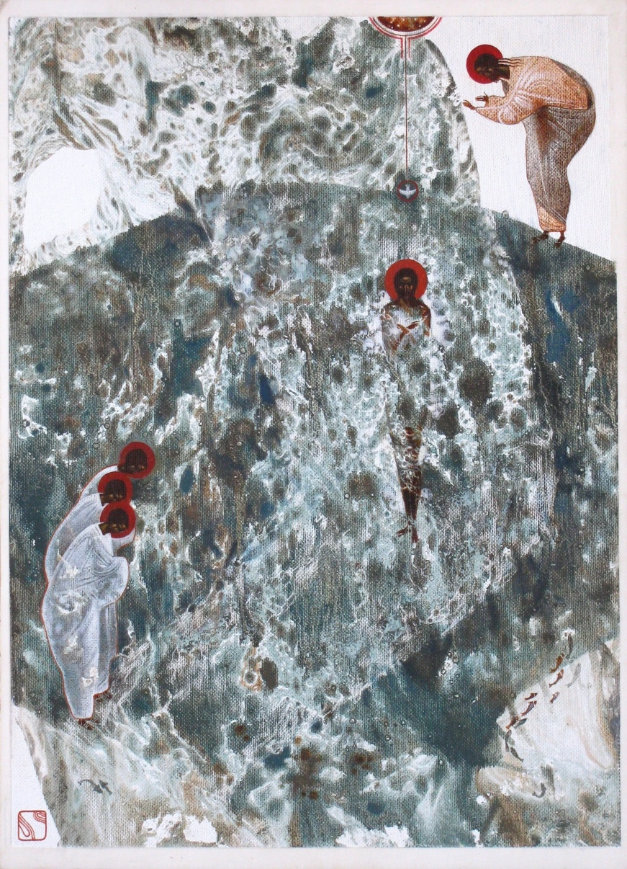

I will pour out pure water on you and you shall be purified.
I will cleanse you of all your stains and of all your idols.
I will give you a new heart.
Ezekiel 36:25

First reading: Matthew 3:13-17
Then Jesus came from Galilee to the Jordan to John, to be baptized by him. John would have prevented him, saying, “I need to be baptized by you, and do you come to me?” But Jesus answered him, “Let it be so now, for thus it is fitting for us to fulfill all righteousness.” Then he consented. And when Jesus was baptized, immediately he went up from the water, and behold, the heavens were opened to him, and he saw the Spirit of God descending like a dove and coming to rest on him; and behold, a voice from heaven said, “This is my beloved, with whom I am well pleased.”

Music: “Wade in the Water” performed by Sweet Honey in the Rock
https://www.youtube.com/watch?v=RRpzEnq14Hs

Second reading: comments from Cynthia Bourgeault on sacramental life, especially baptism and eucharist.

In my own lived experience Eucharist precedes baptism. The change comes from the center of your being where Christ transforms you from the inside out to enable you to embrace baptism as the acknowledgement of your choice that is a witness to the world given you by the grace of God.

It is really the Holy Spirit that is unfolding the soul from God rather than motivating the soul to God.

Music: “Wade in the Water” performed by The Spirituals
https://www.youtube.com/watch?v=fxZ4H-gq_lc

Time of Silent Contemplation

Almighty, everlasting God, look with favor on your servants, whom it has pleased you to call to this step in faith. Rid us of all inward blindness. Sever all snares of confusion or self-deception which heretofore bound us. Open wide for us the door to your love. May the seal of your wisdom so penetrate us as to cast out all temptation and error, and let in the fragrance of your true teachings. Thus shall we serve you gladly and grow daily more perfect. Amen.

—adapted from the Old Catholic Rite of Baptism

Communal Blessing

Music: “Wade in the Water” played for Jazz Vespers at the Washington National Cathedral
https://www.youtube.com/watch?v=Ys6Ukk5PwxY

