Contemplative Service for November 29, 2023

First Week of Advent: Hope

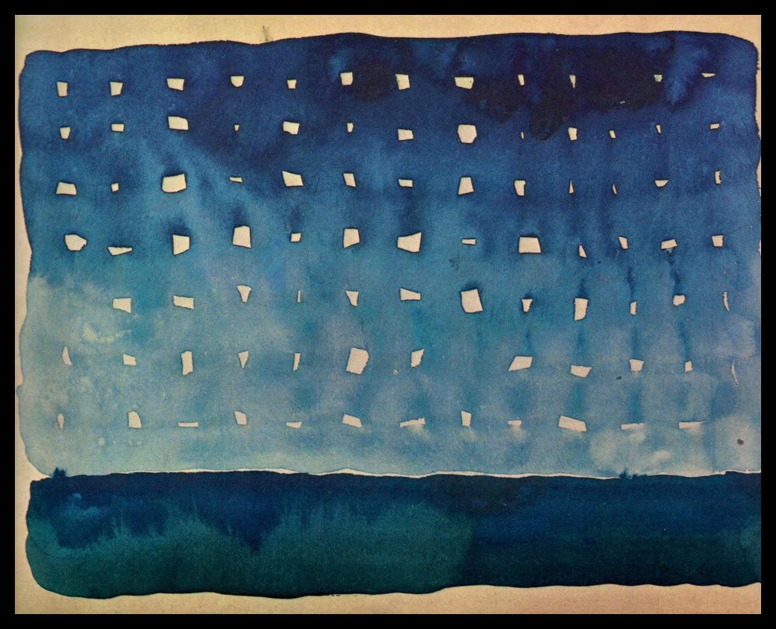

Starlight Night, by Georgia O’Keefe

First reading: from Psalm 27

One thing have I asked of you, Holy One,
that will I seek after:
that I may dwell in your presence
all the days of my life,
to gaze upon your beauty
and to inquire in the holy temple.
For the Divine One will hide me and shelter me
in the day of trouble.
And now my head shall be lifted up
above my travails all around me,
and I will offer shouts of joy;
I will sing and make melody to God.
You have said, “Seek my face.”
My heart says to you,
“Oh, I do. Your face I do seek.”
Teach me your way, O Path and Light,
and lead me on in hope.
Give me not up to the will of my despair.
I believe that I shall look upon the goodness of the God
in the land of the living.
Wait in hope; be strong, and let your heart take courage.
Music: “A’Chuthag” performed by Natalie McMasters
https://www.youtube.com/watch?v=iXardFV0FKE

Second Reading: A quote from Howard Zinn

To be hopeful in bad times is based on the fact that human history is not only of cruelty, but also of compassion, sacrifice, courage, kindness. If we see only the worst, it destroys our capacity to do something. If we remember those times and places where people have behaved magnificently, this gives us the energy to act. And if we do act, in however a small way, we don’t have to wait for some grant Utopian future. The future is an infinite succession of presents, and to live now as we think human beings should live, in defiance of all that is bad around us, is itself a marvelous victory. Howard Zinn.

Music: “Julia’s Waltz” performed by Natalie McMasters
https://www.youtube.com/watch?v=AUWHOvGiK74

Time of Silent Contemplation

Grant me, O Lord my God, a mind to know you, a heart to seek you, wisdom to find you, conduct pleasing to you, faithful perseverance in waiting for you, and a hope of finally embracing you.

—Thomas Aquinas

Communal Blessing
Holy One,
Hope is our daily conversation with you. It is like all conversations—inflected by surprise, disappointment, change, satisfaction. We pray that the conversation becomes ever deeper, growing, above all, from our mutuality. Our hope grows as we shape and share it. And what we share with you, Divine Love, we promise to share with others, and with all creation. It is in this hope that we pray. Amen.

Music: “Volcanic Jig” performed by Natalie McMasters
https://www.youtube.com/watch?v=NAqdZWO6QA0

May you be fed by, and share the sustenance of, hope.

