Contemplative Service for Wednesday,
April 24, 2024

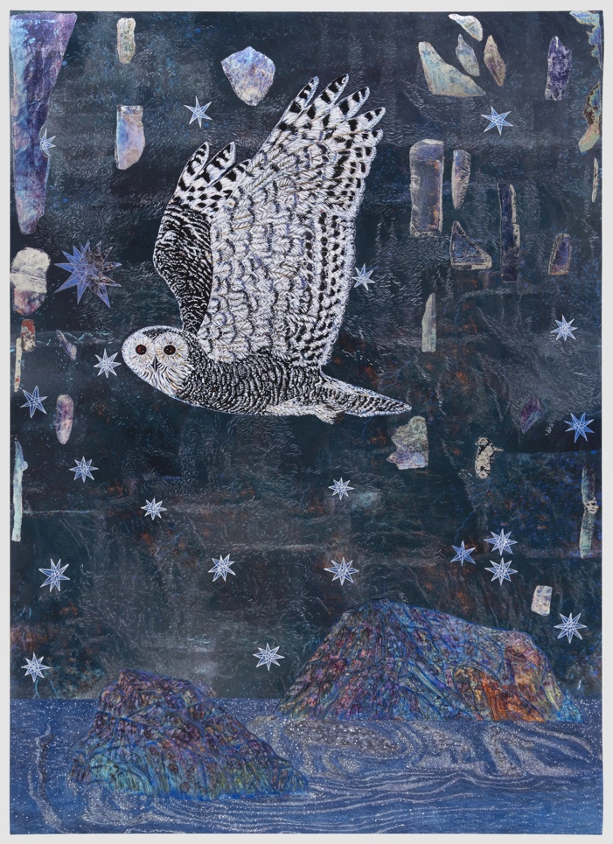
Image by Kiki Smith

We live in unknown spaces and give ourselves over to following something unknown.
—Kiki Smith

First reading: Psalm 119: 105

Your word is a lamp before my feet and a light illumining my path.

Music: “Sacred Journey” by Douglas Thunder Horse

https://www.youtube.com/watch?v=nCGuSWrSXMo

Second reading: “A Blessing” by James Wright

Just off the highway to Rochester, Minnesota,
Twilight bounds softly forth on the grass.
And the eyes of those two Indian ponies
Darken with kindness.
They have come gladly out of the willows
To welcome my friend and me.
We step over the barbed wire into the pasture
Where they have been grazing all day, alone.
They ripple tensely, they can hardly contain their happiness
That we have come.
They bow shyly as wet swans. They love each other.
There is no loneliness like theirs.
At home once more,
They begin munching the young tufts of spring in the darkness.
I would like to hold the slenderer one in my arms,
For she has walked over to me
And nuzzled my left hand.
She is black and white,
Her mane falls wild on her forehead,
And the light breeze moves me to caress her long ear
That is delicate as the skin over a girl’s wrist.
Suddenly I realize
That if I stepped out of my body I would break
Into blossom.

Music: Ko Te Pu Karakia Timatanga Tu Maori

https://www.youtube.com/watch?v=aRIjMCBclg8

Time of Silent Contemplation:

Let us vow to bear witness to the wholeness of life,
realizing the completeness of each and every thing.
Embracing our differences,
I shall know myself as you,
and you as myself.
May we serve each other
for all our days,
here, there, and everywhere.
Let us vow to open ourselves to the abundance of life.
Freely giving and receiving, I shall care for you,
for the trees and stars,
as treasures of my very own.
May we be grateful
for all our days,
here, there, and everywhere.
Let us vow to forgive all hurt,
caused by ourselves and others,
and to never condone hurtful ways.
Being responsible for my actions,
I shall free myself and you.
Will you free me, too?
May we be kind
for all our days,
here, there, and everywhere.
Let us vow to remember that all that appears will disappear.
In the midst of uncertainty,
I shall sow love.
Here! Now! I call to you:
Let us together live
The Great Peace that we are.
May we give no fear
for all our days,
here, there, and everywhere.

—“A Blessing for the Journey” by Sensei Wendy Egyoku

Communal Blessing

May our steps be graceful even when we are lost.
May we find reason to be grateful for our lostness.
May be give thanks for all that we find, and in the seeking,
be found ourselves.
May the stillest moments be a deepening of the journey.
In you, then, Loving One: grace, gratitude, and the centering stillness
that we call home. Amen.

Music: “Ororuatangi-Ia: Putorino Flute

https://www.youtube.com/watch?v=mVs3j28tub4

May the Divine protect us, love us,
And guide us in doing good work.
Let the flow of the sacred meaning give us energy and life.
Join. Gather. Unite.
A Maori blessing

