Order of Worship for Sunday, April 16, 2023

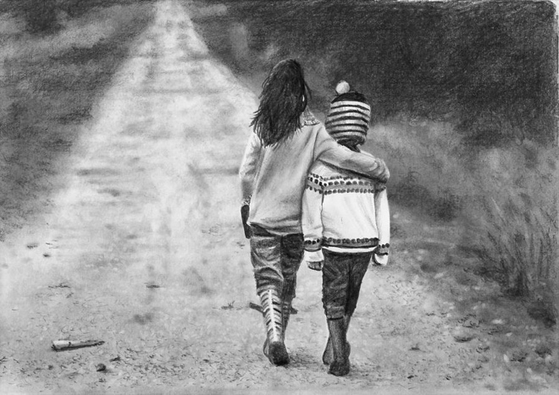
Art by Nolan Clark

Lay reader: Jeane Samuelsen

Reflection: Now there is only the future from the future, the one we can’t see, because it is unseeable, unjudgeable, but being so it is also unlimited, lawless, written, if it is written anywhere, on the tablets of our hearts.

See the door, see the pitch black passage, see us walking blind but OK, walking into an unknown that is not an enemy, but a possibility, even a destiny. And that’s my story now.
—Joe Bardin

Call to Worship

One: We have made the passage from life to death,
and yet our work is not done.

All: How do we understand who and where we are?
Perhaps we never will.

One: But we do step forward in grace toward your love.
We do walk the tightrope of this life in faith.

All: You are our balance, God.
When we teeter you right us.

One: We surrender to you, Loving Guide.

All: Your hand upon us brings sure direction to our scattered steps.

Community Prayer
Patient God, in Easter’s light, the world shines more vividly. Within this great good news, we are a little dizzy. Who are we now in the freedom of this abundant life? We thought we had come to the end, only to find that we are smack in the middle of all that you call us to be. May our focus be true. May be see the world truly through a holy lens. And may we always choose your flourishing light.
Amen.

Scripture readings:

John 18: 4-11
Jesus, knowing all that was to happen to him, came forward and asked them, “Whom are you looking for?” They answered, “Jesus of Nazareth.” Jesus replied, “I am he.” Judas, who betrayed him, was standing with them. When Jesus said to them, “I am he,” they stepped back and fell to the ground. Again he asked them, “Whom are you looking for?” And they said, “Jesus of Nazareth.” Jesus answered, “I told you that I am he. So if you are looking for me, let these people go.” This was to fulfill the word that he had spoken, “I did not lose a single one of those whom you gave me.” Then Simon Peter, who had a sword, drew it, struck the high priest’s slave, and cut off his right ear. The slave’s name was Malchus. Jesus said to Peter, “Put your sword back into its sheath. Am I not to drink the cup that the Father has given me?”

Luke 23:39-43
One of the criminals hanging beside him scoffed, “So you’re the Messiah, are you? Prove it by saving yourself—and us, too, while you’re at it! But the other criminal protested, “Don’t you fear God even when you have been sentenced to die? We deserve to die for our crimes, but this man hasn’t done anything wrong.” Then he said, “Jesus, remember me when you come into your Kingdom.” And Jesus replied, “I assure you, today you will be with me in paradise.”
Luke 24: 28-31 As they approached the village to which they were going, Jesus continued on as if he were going farther. But they urged him strongly, “Stay with us, for it is nearly evening; the day is almost over.” So he went in to stay with them. When he was at the table with them, he took bread, gave thanks, broke it and began to give it to them. Then their eyes were opened and they recognized him, and he disappeared from their sight.

Sermon Title: How to Navigate the Middle Way

Possible hymns:
BH 83 I Sing as I Arise Today
BH 249 Peace I Leave with You, My Friends
BH 256 We Live By Faith and Not by Sight
BH 85 I Woke Up This Morning

