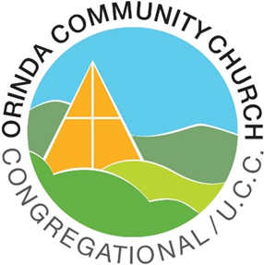

Orinda Community Church
ORDER OF WORSHIP
An Open and Affirming Congregation of the United Church of Christ
Reverend Elizabeth Robinson, Senior Pastor
Sunday, August 13, 2023, 10:00 a.m.

Reflections:
Faith is to believe what you do not see;
the reward of this faith is to see what you believe. —St. Augustine

from a print by Hokusai
WE GATHER

PRELUDE Nik Nackley
BRINGING OF THE LIGHT & RINGING OF THE HOUR The Acolytes
WELCOME Reverend Elizabeth Robinson

INTROIT

CALL TO WORSHIP* from Psalm 85 a litany by Kathi Kling
One: Let us hear what God will speak, for the Holy One will speak peace
to the people, to the faithful, to those who turn their hearts to God.
All: Surely our Loving One is at hand to restore those who reach out
in faith. May we become signs of God’s presence wherever we go.
One: Steadfast love and faithfulness will meet; righteousness and peace
will kiss each other.
All: Faithfulness will spring up from the ground, and righteousness
will look down from the sky. Righteousness unfolds from God’s
presence, and makes a path so that God may walk among us.

HYMN Black Hymnal 510 Grant Us Wisdom to Perceive You German Carol,
14th c.

Stand as you are able
COMMUNITY PRAYER Kathi Kling

Healer, you are the steadfast touch that guides us in darkness.
Your voice brings harmony to dissonance. Help us to trust this.
We see a world of impossible problems. You, God, open to us as an impossible miracle of joy, unity, and restoration. Help us to trust this! Today we discard our fatalism like a ragged cloak. Now we are clothed in your loving impossibilities, bathed in your light, entirely alive with your love. Amen.

WORDS OF ASSURANCE
One: The peace of Christ be with you.
People: And also with you.

WE LISTEN
SOLO Chris Jackson

SCRIPTURE READING: Matthew 14:22-33 Kathi Kling
Immediately Jesus made the disciples get into the boat and go on ahead to
the other side, while he dismissed the crowds. And after he had dismissed the crowds, Jesus went up the mountain by himself to pray. When evening came,
he was there alone, but by this time the boat, battered by the waves, was far from the land, for the wind was against them. And early in the morning he came walking toward them on the sea.
But when the disciples saw him walking on the sea, they were terrified, saying,
"It is a ghost!" And they cried out in fear. Immediately Jesus spoke to them and said, "Take heart, it is I; do not be afraid." Peter answered him, "Lord, if it is you, command me to come to you on the water." He said, "Come." So Peter got out of the boat, started walking on the water, and came toward Jesus. But when he noticed the strong wind, he became frightened, and beginning to sink, he cried out, "Lord, save me!" Jesus immediately reached out his hand and caught him, saying to him, "You of little faith, why did you doubt?"
When they got into the boat, the wind ceased. And those in the boat worshiped him, saying, "Truly you are the Son of God."

SERMON Reach Out Your Hand Reverend Elizabeth Robinson

WE RESPOND

HYMN Black Hymnal 349 I Come With Joy Southern Harmony,
1835

A TIME OF PRAYER Reverend Elizabeth Robinson
JOYS AND CONCERNS
PASTORAL PRAYER
OUR LORD’S PRAYER
Our God, who art in heaven, hallowed be thy name.
Thy kingdom come.
Thy will be done on earth as it is in heaven.
Give us this day our daily bread.
Forgive us our debts as we forgive our debtors.
Lead us not into temptation, but deliver us from evil.
For thine is the kingdom and the power and the glory forever. Amen.

Stand as you are able
MOMENT FOR ANNOUNCEMENTS

OFFERTORY SOLO Chris Jackson

DOXOLOGY Red Hymnal 94 LASST UNS ERFREUEN
Praise God from whom all blessings flow;
Praise God, all creatures here below;
Alleluia! Alleluia!
Praise God for all that love has done;
Creator, Christ, and Spirit, One.
Alleluia! Alleluia!

HYMN Black Hymnal 478 I’ve Got Peace Like a River
Spiritual
BENEDICTION* Reverend Elizabeth Robinson
POSTLUDE Nik Nackley

Thank you to this week’s ushers:
Marilyn Welland, Jill Oberheim, Betty Wu, and Lani Shepp

Stand as you are able.
Orinda Community Church
10 Irwin Way, Orinda, CA 94563
(925) 254-4906
office@orindachurch.org
Reverend Elizabeth Robinson, Senior Pastor
David Milnes, Director of Music
Anna Gregory, Office Administrator

EVENTS
In addition to 10 am Sunday worship, we offer
Weekly:
Monday mornings at 9:30 a.m. in the Chapel, we host Centering Prayer.

Wednesday mornings at 10:00 a.m., we hold a brief Contemplative Service in the chapel, which includes readings, music, prayer time, and silence. This service also goes out electronically.

Thursday Life and Loss Group in the Fireside Room from 12:15 to 1:45 pm. You are welcome to simply attend, or if you have questions, please call or email the office.
Thursday afternoons at 2:00 p.m., our Theology and Scripture group meets via Zoom to discuss theology and the bible, and other topics. The next meeting is Thursday, August 10, at 2:00 pm.

And these, every other week:

Two Tuesdays a month, the Writers Group shares and discusses their writings via Zoom at 10:00 a.m. The next meeting is Tuesday, August 8.

Two Thursdays a month, starting at 3:45 p.m., the Reading Group meets via Zoom. Our next meeting is Thursday, August 10, at 4:00 p.m. The room opens at 3:45 p.m. for welcome and chatting.
2nd Hour
The Reading Group is holding a 2nd Hour Presentation (date to be announced) about the book Poverty, by America
by Pulitzer Prize winning author, Matthew Desmond.
We encourage you to begin reading now so that you can
be part of the discussion when we meet!

______________________________________
COFFEE HOUR SIGN-UPS
The ushers have the Coffee Hour sign-up clipboard.
We are looking for August and September Volunteers.
If you’re able to take on this greatly appreciated service
for one Sunday, please sign up today!

_____________________________________

The next Church Council Meeting is
Wednesday, August 23rd at 7:00 p.m.
Keep an eye out for the Zoom link in your
e-blasts if you would like to attend virtually.
Every Tuesday, Frog Hollow drops off boxes of fruit and folks that have signed up for weekly or bi-weekly boxes pick them up.

They also offer eggs, olive oil, cheese, pasture raised meats, spices, sauces, coffee, fruit spreads, honey, and much more!

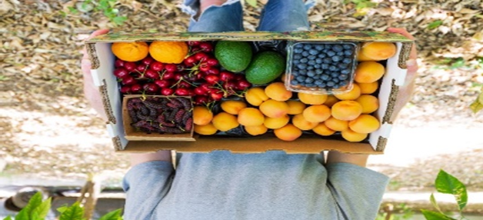
It’s easy to sign up, go to www.froghollow.com and choose Orinda as your pick-up location. The boxes are deposited on the parking lot side of Fellowship Hall for pickup.

Questions? You can ask Anna in the office, or go to their website www.froghollow.com or email them at csa@froghollow.com
_____________________________________

Alta Mesa Center for the Arts
Alta Mesa Center for the Arts,
under the leadership of Mary Volmer,
is an interfaith arts and spirituality hub,
housed within and sponsored by
Orinda Community Church
GRIEF SUPPORT GROUP
~LIFE AFTER LOSS~

Every Thursday from 12:15 pm – 1:45 pm,
the Life After Loss group meets in the Fireside Room,
under the guidance of Reverend Gillian Murphy-Stephans.

No sign-up is necessary.

For any questions, please contact the office at
925-254-4906 or by email: office@orindachurch.org

