Reflection for Monday, March 6, 2023

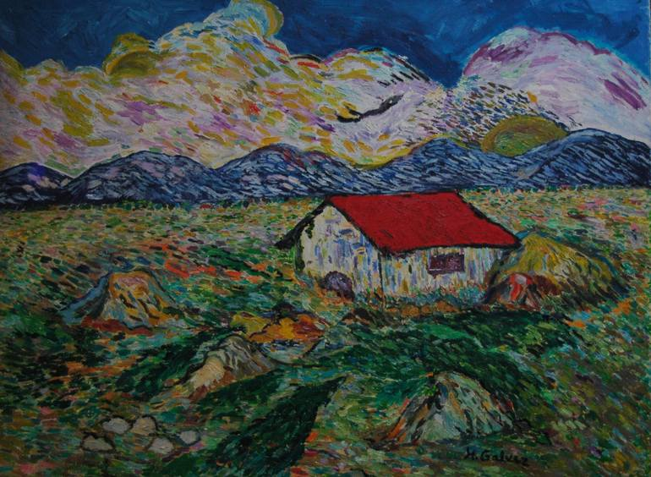
Painting by Richio Galvez

When I was going through my divorce, I dealt with my semi-homeless state by housesitting for friends. And what I remember about it was the unnerving feeling of never knowing where anything was. Where were the towels? Where was the dog’s leash? Why can’t I find the mugs? It occurs to me that being at home is in some ways marked by knowing where things are so that you can move seamlessly through your environment and really engage with what each day requires.

But as Gary Nye’s moving poem below makes clear, “home” isn’t necessarily a static thing. As a child, he found it in his relationships with his parents: that made home no matter how frequently they moved. And so, for Lent, we try to live the presence of “home” more deeply, finding that place within us where God lives and everything is in order. With God’s love as our resource, we pray that we will not be knocked off balance by the tumult of the world and move seamlessly through the day in harmony with God’s call to us.

In faith,
Elizabeth

Home

When I was a child, we moved a lot.
We, the family, included: my father, my mother, and me.
That package was home for me.
Wherever we were and whatever the setting,
that package was home.

God was in the mix too.
I might be going to Sunday School, but not always.
And depending on each town it could be
A different church and a different denomination.
I am sure whatever my concept of God might have been,
At whatever age I was, God was there. And that was good.

Mom and Dad rarely attended church, but I went to Sunday school,
And that was OK by me. It was usually interesting.
Mom and Dad didn’t discuss religion a lot, unless it was something of an opinion, as to
why they didn’t believe this or that. They didn’t quote the Bible, but Dad liked to quote the
Rubaiyat. For Mother I think it was mostly about Love.

So wherever we were going- even when we moved,
I felt we were home, and God was there too.

Gary Nye

Announcements

Elizabeth will be away next weekend, and we are delighted to have Lee Cruise preaching for us.

Please join us for a Second Hour presentation in the Fireside next Sunday, March 12. Lucina Lopez, who is currently living in the church cottage, will be telling us about her work with Interfaith Movement for Human Integrity (where she was just named Employee of the Month!) accompanying undocumented immigrants, and also about her work with sanctuary churches in the Bay Area. We are delighted to have Lucina talking with us and hope you will attend.

