Reflection for Monday,
April 14, 2024

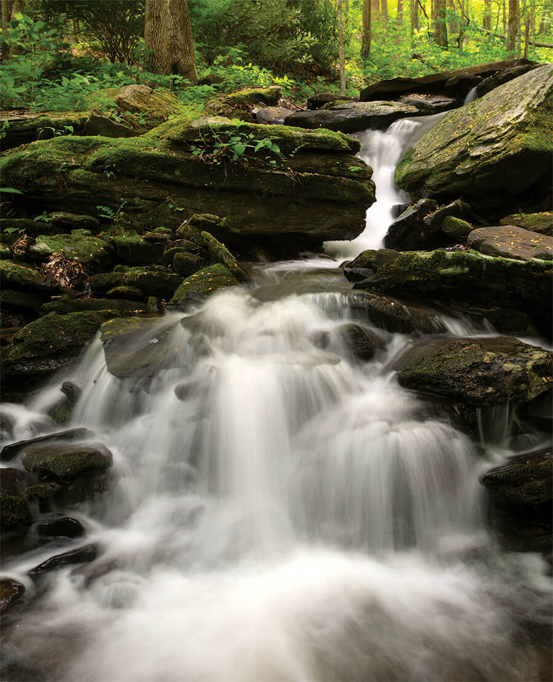

The Writers’ Group had an unexpected delight last week. I had given the writers the challenge of writing about spring—but with no narrative, no events: just close attention and description of the natural world. Among the wonderful writing that got shared was a piece by Poppy, Tom and Paula Beatty’s granddaughter. She even joined us on Zoom, fresh-faced and alert from the U.K. after having spent all night flying across the Atlantic. Here is what Poppy shared with the group, and now with all of you:

A canopy of trees, their leaves dappled with flecks of golden sunshine, hung over a glistening waterfall. The rushing water fell between two gigantic silver boulders, gleaming in the sunlight like a fairy godmother's light, wispy hair. Spray from the waterfall splashed onto the faces of the dazzled people watching the spectacular scene, before it landed in a sky-blue pool below.
—Poppy (age 9)

It creates a gorgeous picture, doesn’t it? I especially like the image of the water and mist gleaming in the sunlight like a fairy godmother’s hair.

Images like this gladden and reassure me. I admit that when news about the climate crisis comes up, I can be avoidant; it’s hard to take in difficult news. But experiences in nature, and images like Poppy’s, remind me that there is so much to love in our complex, beautiful world. That wonder and beauty helps me to reignite my commitment to climate justice and a more whole vision of God’s living, evolving creation.

So I hope you will join me in celebrating our beautiful planet next Sunday. I invite you to come to church with some of your favorite wild and natural places in mind. And after we celebrate God’s lush creation, we can head off to The Good Table in El Sobrante and celebrate their first Sunday farmer’s market with them!

So glad to live within all these blessings with you.

In faith,
Elizabeth

Announcements:

On April 26, there will be two events of interest to members of the church community.
Take your pick!

On April 26 the Premiere of two films made about the play Victoria Rue co-wrote and directed will be presented at Rossmoor. The play was "Voices from the Silenced: Pre- Roe Abortion Stories."

Victoria would love anyone from the church to come on April 26---but you have to notify her ahead so she can register your name at the gate (victoria.rue@sjsu.edu). The tickets are free, though donations will be requested. Below is the poster for the event on April 26, plus 2 trailers for the 2 films. Hope you can come!

TRAILER of DOC: https://www.youtube.com/watch?v=AyEWAArAy5M
TRAILER OF FILM OF THE PLAY: https://vimeo.com/928112336

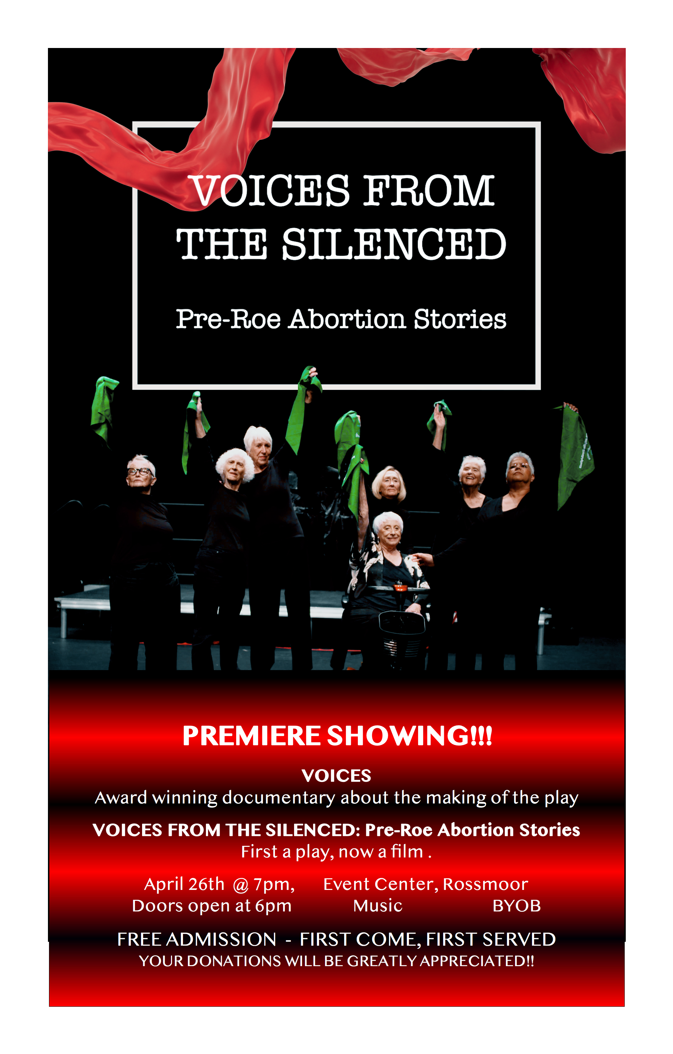

Also on April 26th at 7:30 p.m. in the church chapel, a poetry reading featuring a new book by Elizabeth Robinson and Susanne Dyckman, translations of Portuguese poet Orides Fontela by Chris Daniels, and art by Jonah Morris (Elizabeth’s son). We will offer refreshments, conversation, and brand new copies of the book, Rendered Paradise.

