Reflection for Monday, September 18, 2023

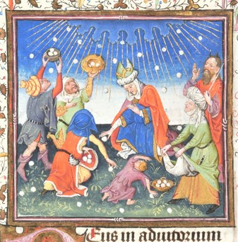
painting by the Master of Catherine of Cleves, 15th Century

The story of manna coming to feed a desperate people is always contemporary. The Israelites in Exodus are so desperate for food that they begin to regret that they have escaped slavery in Egypt. They are hungry. The desert doesn’t offer much provision. They are irascible and nothing is good enough: God sends quail, and they get sick of eating quail.

The story is always timely because there are always desperately hungry humans, and, even when fed, humans have a tendency to worry if they will have enough, to want more.

As we begin our stewardship season, I am grateful that Bill Abriel directed our minds and hearts to hope. Manna helped a lost people to regain their hope: that they had enough and would have enough.

I love the image above in which people come together to gather manna as it falls from the heavens. It reminds me that we gather together what God gives and then we share it. But what I really love is the child in the middle at the bottom of the picture. He looks like he’s lobbing a manna snowball—yup, like this gathering of provisions is actually fun.

Hope isn’t just grim determination to carry on, it is also joy. And so I look at that boy and I think back to the good company and good spirits of our homecoming lunch. People eating, talking, and posing in feather boas and ridiculous clown glasses at the photo booth. I was infected with the hilarity as I watched people posing and laughing and throwing their arms around each others’ shoulders. Stay tuned for pictures!
And if our Amnesty International letters didn’t garner many signatures? No worries. I will have them on hand again next Sunday. Yesterday was a day for gathering the manna of fellowship, hope, and joy.

In gratitude and faith,
Elizabeth

