Summer Whimsy:
Creative Reflections for Monday,
July 10, 2023

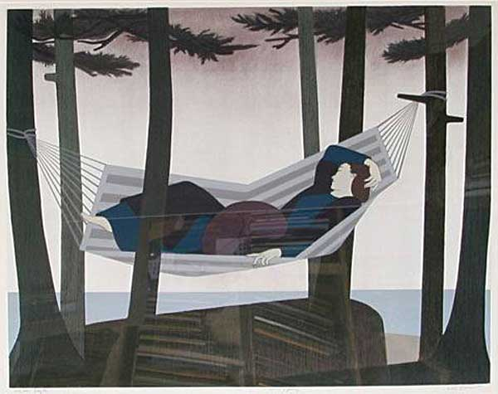
art by Will Barnet

When I was Ten Years Old

When I was ten years old, Russ Hodges announced the Giants games and Willie Mays played center field under my covers on my transistor radio during every night game, and my parents never knew.

When I was ten years old, I thought almost all girls were ridiculous and truly might have cooties…except for Karen Wynard. Oh my. She was different. First crush.

When I was ten years old, I got a speedometer/odometer for my bike and my inner OCD raged as I drove to great speeds and distances and sometimes disappointing lows.

When I was ten years old, I discovered how to manipulate the coke machine at the swim center and took advantage of it religiously until the day came when a cup didn’t drop and the coke ran forever.

When I was ten years old, Kennedy was shot a few days after my family saw PT 109. When I yelled to my parents to come into the TV room, announcing that Oswald was shot, they didn’t believe me.

—Tom Beatty

**

Summer Memories

Out on the lake, watching my. family bob up and down in a boat.
Out on the lake, eating fried chicken my sister in-law lovingly prepared.
Out on the lake, not stressing about the world’s problems.
Out on the lake , rejoicing about the beauty of the water surrounding us.
Out on the lake, feeling grateful for the wind and the water and the sun.
Out on the lake, laughing and being silly.
Out on the lake, remembering all the other familiar times…dancing and listening to Michael Jackson with my husband Jim.
Janet Schwartz
Many thanks to Janet and Tom for sharing their creative reflections.

