Contemplative Service for Wednesday,
January 24, 2024

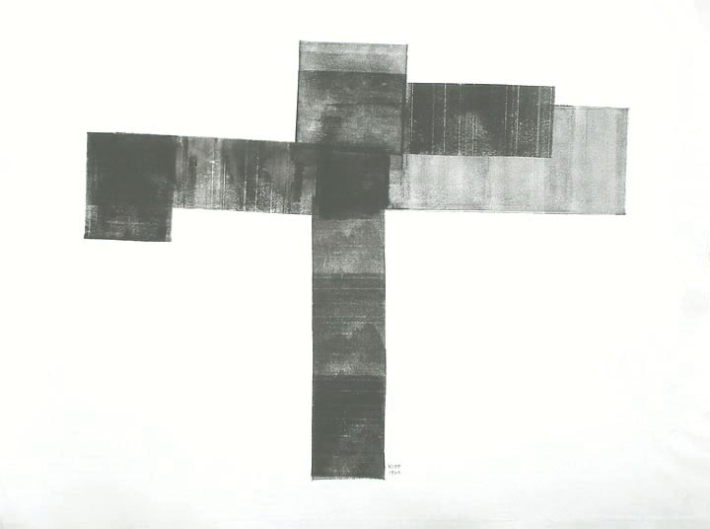
Image by Lyman Kipp

First reading: I Corinthians 8: 2-3

Anyone who claims to know something does not yet have the necessary knowledge; but anyone who loves God is known by God.

Music: “My Song is Love Unknown” performed by Folks and Hymns
https://www.youtube.com/watch?v=DvYKv_rwM6E

Second reading: from “Philosophy, Truth, and the Wisdom of Love” by Lambert Zuidervaart

The very words in which Western philosophy has described its vocation—truth, love, wisdom—are spiritually loaded terms; in the Jewish and Christian scriptures, these terms do not mean what many philosophers have taken them to mean. So Christian philosophers must reconceive the meaning of these terms […] I want to explore what this might require in our understanding of truth.

In the Jewish scriptures, the primary meaning of truth (emeth) is not accuracy or correctness. Instead, emeth means faithfulness, and it pertains both to God and to human beings. To be true, in the first instance, is not simply to be correct but to be faithful in relationship to others. God is true in faithfully carrying out God’s Word of promise for creation, and human beings are true when their dealings are faithful to the conditions of God’s promise. That is why Calvin Seerveld says truth in the scriptures means “God’s blessing presence is in evidence” in human life.

Parmenides, a pre-Socratic poet-philosopher […] aligns truth with being that does not change. The Jewish and Christian wisdom traditions turn such an esoteric conception of truth upside down. Affirming that God created everything good, and recognizing temporal change and interconnections as intrinsic to created goodness, they do not align truth with unchanging and self-sufficient being. Nor do they connect wisdom with knowing immutable truth. Instead, Judeo-Christian “truth” has to do with blessed faithfulness within relationships and amid change, and “wisdom” pertains to instruction for faithful living, for lives of loving God and neighbor. All human beings, including philosophers, are called to live in and live out the truth.

Hope for a future where love and truth meet has ripple effects in the present, both in our seeking the good and in our resisting evil. Living in such hope, we can neither regard our current dealings and practices and institutions as fully “in the truth” nor despair over the depth and power of societal evil.

Music: “The Water is Wide” performed by Folks and Hymns
https://www.youtube.com/watch?v=xVcKPeQMQbk

Music: “Humble Hymn,” by Kristjana Stefans and Svavar Knutur
https://www.youtube.com/watch?v=SKvapGWN1W8

Time of Silent Contemplation

Come, my Way, my Truth, my Life:
Such a Way, as gives us breath:
Such a Truth, as ends all strife:
Such a Life, as killeth death.
Come, my Light, my Feast, my Strength:
Such a Light, as shows a feast:
Such a Feast, as mends in length:
Such a Strength, as makes his guest.
Come, my Joy, my Love, my Heart:
Such a Joy, as none can move:
Such a Love, as none can part:
Such a Heart, as joys in love.
—George Herbert

Communal Blessing

One in Wholeness and Grace,
We pray that we can take the small pieces of what we know and construct something that is made of love—made for love. Our sense of truth, as brittle and fragile as it is, can grow from your compassion into wisdom. Make us whole, we pray, with and through your love. Amen.

Music: “’Tis a Gift to be Simple” performed by Saint Andrews Episcopal Church
https://www.youtube.com/watch?v=4RPUjuraS5U

May our wisdom come forth supple and in kind.

