Contemplative Service for Wednesday,
April 12, 2023

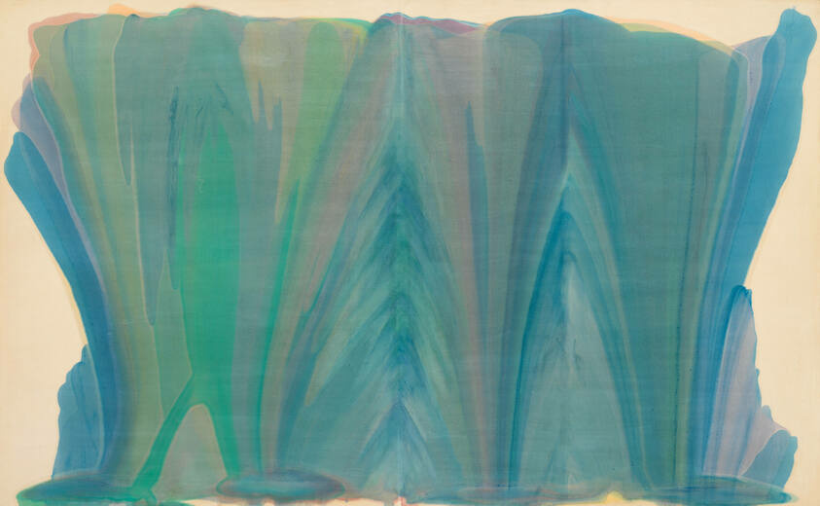
Painting by Morris Louis

First reading: Colossians 1: 17

The Holy One, our Source, is before all things, and in that Source all things hold together.

Music: “Dream,” by John Cage
https://www.youtube.com/watch?v=9hVFCmK6GgM

Second reading: from “A Sunlit Absence,” by Martin Laird

Saint Teresa of Avila was amazed to discover that in her own daily life interior struggle and deep, bedrock peace often occurred together. She states with her customary authority: “Just because the soul sits in perpetual peace does not mean that the faculties of sense and reason do, or the passions. There are always wars going on in the other dwellings of the soul. There is no lack of trials and exhaustion. But these battles rarely have power anymore to unseat the soul from her place of peace.”

Music: “Peace Piece,” by Bill Evans
https://www.youtube.com/watch?v=ffnnMC-yMR0

Time of Silent Contemplation

Peace and happiness are available in every moment.
Peace is every step. We shall walk hand in hand.
There are no political solutions to spiritual problems.
Remember: If the Creator put it there, it is in the right place.
The soul would have no rainbow if the eyes had no tears.
—Cherokee Prayer

Communal blessing:

Perhaps a little imbalance, a little unevenness, is a good thing, God. Humans believe that symmetry is beautiful, but you have created a world in which not all wholes can be divided in half. We look to you in surprise at the way the broken bark of a tree is alive with color or the rasp of a beloved voice takes on special harmony. We try to put away our clumsiness because we can’t see the glow of it. Open to us, we who are your awkward beings. We awaken, stiff and blurred, and you are waiting for us with the morning light. Amen.

Music: “Did You Think to Pray,” performed by Brigham Larson
https://www.youtube.com/watch?v=bxmnOApK6V4&list=PLyNKX1HDiPPELZe_9qWnXwkIAuLRpOLe_

May peace be yours in ups and downs, imbalance and balance.

