Contemplative Service for Wednesday
April 5, 2023

A Tenebrae Service

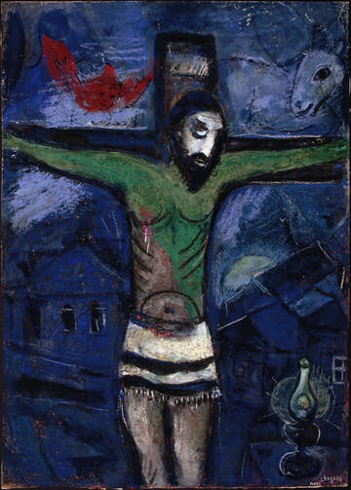
painting by Marc Chagall

First reading: John 19:29-30

So they put a sponge full of the wine on a branch of hyssop and held it to his mouth. ³⁰ When Jesus had received the wine, he said, “It is finished.” Then he bowed his head and gave up his spirit.

Music: “The Lamb” by John Tavener, conducted by Nigel Short
https://www.youtube.com/watch?v=HRjeC31edk0

Second reading: “Cyclic Journey Thru Cross Roads” by Norman Weinstein

In a dark church all senses shed
an impulse to get to a destination
blinded directionally in silence, as if
entering a garden where olive trees
whisper braille. We go among their gnarled
branching arms where they wish to go,
not simply to go with God but God goes
on a journey our own. Somewhere
in this poem a compass needle becomes
an arm holding a chalice. Of blood merging
with blood to create a church where
silence, roughly sanded, polishes into Psalm.
Olive tree branches like usher arms push
us forward into a black we’ve not left
In our rush to get anywhere but this
remaining Cross roads.

Music: “Miserere mei, Deus” by Allegri, conducted by Nigel Short
https://www.youtube.com/watch?v=H3v9unphfi0

Time of Silent Contemplation:

Save me, O God,
for the waters have risen up to my neck,
and there is no firm ground for my feet.
My eyes have failed from looking for my God.
O God, you know my foolishness,
and my faults are not hidden from you.
In your great mercy, O God,
answer me with your unfailing help.
Save me from the mire; do not let me sink;
let me be rescued.
Answer me, O LORD, for your love is kind.

—from Psalm 69

Communal Blessing

Bless the dark.
Bless the absence.
Bless this irremediable.
Bless the groping toward.
Here in this blessing we wait.
Bless us, bowed and bound in misgiving.
Bless the sheen of tears in no light.

Music: “If Ye Love Me,” by Tallis, conducted by Nigel Short
https://www.youtube.com/watch?v=HI5Y9l2NHIo

May you feel the divine presence even in the deepest shadow.
Go in peace.

