Contemplative Service for Wednesday,
March 27, 2024

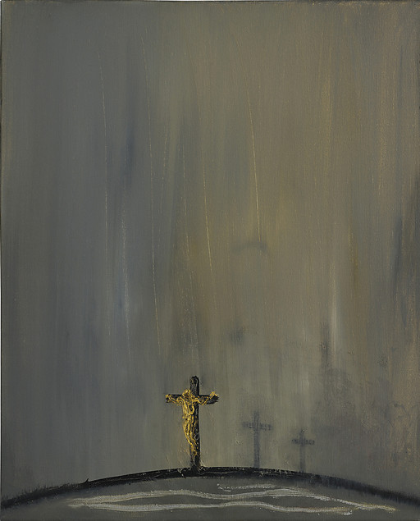

Painting by Maggi Hambling

First reading: Psalm 27:13

I would have despaired if I had not believed that I would see the goodness of God in the Land of the Living.

Music: Chant de Veillee Funebre, by Paodi
https://prophet-label.bandcamp.com/track/paodi-chant-de-veill-e-fun-bre

Second reading: Responses of incarcerated men to one of Jesus’ last utterances.

“I thirst.”
I thirst to have my son back in my life.
Fill my life with the only living water that is capable of quenching my thirst.
I thirst for my wrongs to be forgiven.
My cup overfloweth, thank you.
Take my thirst.
It’s unavoidable.
I am afraid to drink, afraid to grow in you, afraid of being loved, cared for, understood.
I thirst for what I know nothing of.

Music: Sanctus, performed by Trouvere Medieval Minstrels
https://trouveremedievalminstrels.bandcamp.com/album/saeculorum

Time of Silent Contemplation

O God,
my heart is a vain heart, a wandering and unstable heart
when it is led by its own judgment and lacking divine counsel,
and it cannot subsist in itself.
When it seeks other ways, it finds nothing,
but remains miserable in its labor, and empty of peace.
It does not agree with itself, it dissents from itself,
it alters resolutions, changes its judgment, frames new thoughts,
pulls down the old, and builds them up again.
It wants and does not want, and never remains in the same state.
Come, Holy Spirit, and bring from heaven a ray of your light!
Blessed Comforter, dear guest of the soul, and its sweetest refreshment!
Our rest in labor, our coolness in heat, oh, cleanse those who are filthy.
Refresh those who are dried up. Heal those who are wounded.
Bend those who are stubborn. Cherish in your heart those who are cold.
Guide those who are wandering.
Grant your servants, who put their trust in you,
the merit of your goodness. Grant them joy!
O Lord, hear our prayer, and let our cry come to you. Amen.
—from a prayer of Bernard of Clairvaux

Communal Blessing

O Sacred Compassion,
This week we journey into the darkness with you.
On the horizon, we struggle to see any light.
In this black moment, let the very dust that coats
our stumbling feet glitter with traces of your presence.
When we weep, “Where are you?” we hold your voice in our own.

Let there be union in the deepest rupture.
For you, we hold the light even when
we are not sure it is there. Amen.

Music: “Merza’s Lament” by Michael Clifford
https://michaelclifford.bandcamp.com/track/merzas-lament

Peace be with you.

