Contemplative Service for Wednesday
October 11, 2023

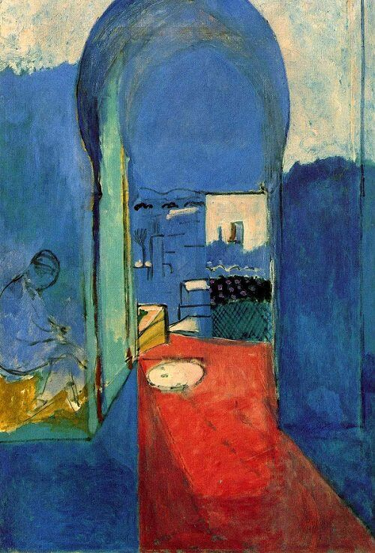

Painting by Henri Matisse

First reading: from Dorothy Day

We know that we constantly err through lack of charity and
prayer, but with confidence in God we can start each morning
anew with the words of the Psalmist, “Now I have begun.”
So pray for us that we have the love and joy in service that
go with all beginnings.

Music: “Stones Start Spinning” by David Darling
https://www.youtube.com/watch?v=2shq7HrN3ok

Second reading: “Welcoming Blessing” by Jan Richardson
When you are lost
in your own life.
When the landscape
you have known
falls away.
When your familiar path
becomes foreign
and you find yourself
a stranger
in the story you had held
most dear.
Then let yourself
be lost.
Let yourself leave
for a place
whose contours
you do not already know,
whose cadences
you have not learned
by heart.
Let yourself land
on a threshold
that mirrors the mystery
of your own
bewildered soul.
It will come
as a surprise,
what arrives
to welcome you
through the door,
making a place for you
at the table
and calling you
by your name.
Let what comes,
come.
Let the glass
be filled.
Let the light
be tended.
Let the hands
lay before you
what will meet you
in your hunger.
Let the laughter.
Let the sweetness
that enters
the sorrow.
Let the solace
that comes
as sustenance
and sudden, unbidden
grace.
For what comes,
offer gladness.
For what greets you
with kindly welcome,
offer thanks.
Offer blessing
for those
who gathered you in
and will not
be forgotten—
those who,
when you were
a stranger,
made a place for you
at the table
and called you
by your name.

Music: “Sunshine Canyon” by David Darling and Michael Jones
https://www.youtube.com/watch?v=0t0MoMof_aE

Time of Silent Contemplation

We awaken in Christ's body
As Christ awakens our bodies,
And my poor hand is Christ, He enters
My foot, and is infinitely me.
I move my hand, and wonderfully
My hand becomes Christ, becomes all of Him
(for God is indivisibly
Whole, seamless in His Godhood).
I move my foot, and at once
He appears like a flash of lightning.
Do my words seem blasphemous? Then
Open your heart to Him
And let yourself receive the one
Who is opening to you so deeply.
For if we genuinely love Him,
We wake up inside Christ's body
Where all our body, all over,
every most hidden part of it,
is realized in joy as Him,
and He makes us, utterly, real,
and everything that is hurt, everything
that seemed to us dark, harsh, shameful,
maimed, ugly, irreparably
damaged, is in Him transformed
and recognized as whole, as lovely,
and radiant in His light
he awakens as the Beloved in every last part of our body.
- Symeon the New Theologian

Communal Blessing
Open eyes, open hands, open throat, open heart—even open mouth!
We open to you, All Holiness, for as we receive you, we become utterly real.
We are both host and guest. You are the breath, the very taste and scent of welcome.
Amen.

Music: “Rainfall” by David Darling and Michael Jones
https://www.youtube.com/watch?v=ZqVvEvMXBzY

Blessings of awakening and welcome to the Spirit.

