Contemplative Service for Wednesday,

February 1, 2023

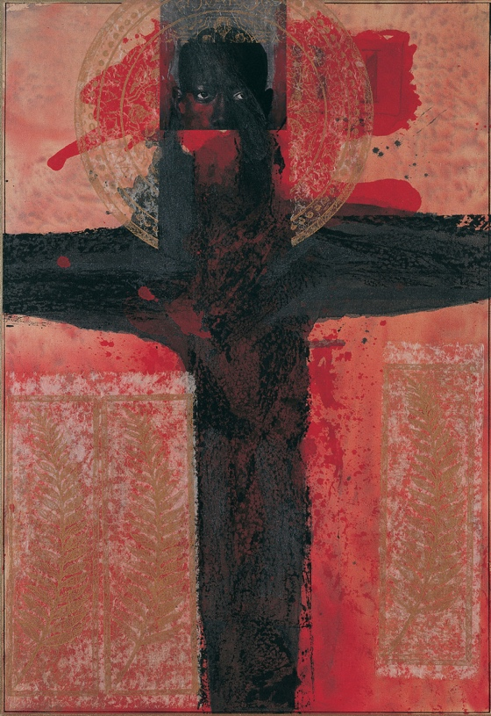

Artwork by Rodriguez Calero

First reading: Isaiah 61:1
The Spirit of the Divine One is upon me, because the God has anointed me to bring good news to the poor; and has sent me to bind up the brokenhearted, to proclaim liberty to the captives, and the opening of the prison to those who are bound.

Music: “Lamento Sertanejo” performed by Quinteto Violado

https://www.youtube.com/watch?v=64n6pnZVmMI&list=PL49dGMGTRrQ8lt_R6Z6CvDpF2csjauc6Z&index=6

Second reading: from Pedagogy of the Oppressed by Paulo Freire

The radical, committed to human liberation, does not become the prisoner of a 'circle of certainty' within which reality is also imprisoned. On the contrary, the more radical the person is, the more fully he or she enters into reality so that, knowing it better, he or she can better transform it. This individual is not afraid to confront, to listen, to see the world unveiled. This person is not afraid to meet the people or to enter into dialogue with them. This person does not consider himself or herself the proprietor of history or of all people, or the liberator of the oppressed; but he or she does commit himself or herself, within history, to fight at their side.

Music: “Marcha Nativa dos Indios Quiriris,” performed by Qinteto Violado
https://www.youtube.com/watch?v=4htM_fbbfko&list=PL49dGMGTRrQ8lt_R6Z6CvDpF2csjauc6Z&index=1

Time of Silent Contemplation

Give us grace, O God, to dare to do the deed which we well know cries to be done. Let us not hesitate because of ease, or the words of men’s mouths, or our own lives. Mighty causes are calling us—the freeing of women, the training of children, the putting down of hate and murder and poverty—all these and more. But they call with voices that mean work and sacrifice and death. Mercifully grant us, O God, the spirit of Esther, that we say: I will go unto the King and if I perish, I perish. Amen.
—W.E.B. Du Bois, from Prayers for Dark People

Communal Blessing

Holy Freedom,
We are growing slowly into what you give us. You are like a tune we hum piecemeal, but it lingers in our minds. Rise in us until you are bare melody, and then more—words, chords, dissonances, harmonies. You swell in us now, a unity, a unison, an anthem. We sing your liberation. May it be so.

Music: “Caranguejo Danado” performed by Nelson do Santos
https://www.youtube.com/watch?v=nSTGk2XDLiE&list=PL49dGMGTRrQ8lt_R6Z6CvDpF2csjauc6Z&index=9

May you live and move in the powerful peace that arises from freedom.

