Contemplative Service for Wednesday
June 7, 2023

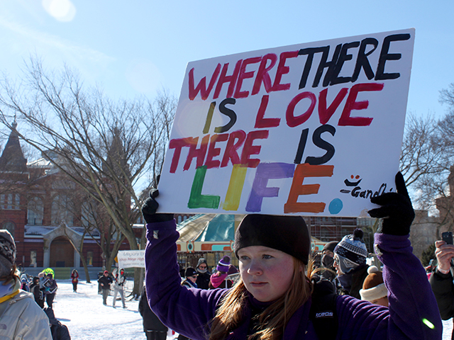

First reading: Hosea 2:18
In that day I will also make a covenant for them
With the beasts of the field,
The birds of the sky
And the creeping things of the ground.
And I will abolish the bow, the sword and war from the land,
And will make them lie down in safety.

Music: “Going Home” sung by Paul Robeson
https://www.youtube.com/watch?v=lMMJCfjuhYM

Second reading: from a reflection by Rev. Michelle Higgins

Good news for our cousins in danger of deportation: borders are not in God’s future.
Good news for survivors: The Lord has come to remind you that evil will be cut off.
Good news for the tribes to whom this land truly belongs: The Lord has promised to make your invaders flee and never return.

God builds power with people participation. Capitalism and the carceral mind define effective safety as the threat of punishment, but God holds all things together with the truth. Creator God raised up every human from water and dust: uncontainable, unpredictable, the stuff of chaos and the ground. We are all made from meager stuff, on purpose.

Jesus’s journey is a series of radical prophetic fulfillments that bring us this good news. Perhaps none so radical than the good news of humanity’s divine sufficiency.

Jesus teaches that godliness requires togetherness. But somewhere along the way, some strange, slavery-based somehow, somebody got it twisted.

Good news – all you who are searching for the God of Love and Help and Freedom, They are already near to you, within you. Freedom is yours; the so-called justice system didn’t give it, no cage can take it away.

Music: “They’ve Got So Much Things to Say” by Lauren Hill
https://www.youtube.com/watch?v=P9dae36nQUM

Time of Silent Contemplation
Open unto me — light for my darkness.
Open unto me — courage for my fear.
Open unto me — hope for my despair.
Open unto me — peace for my turmoil.
Open unto me — joy for my sorrow.
Open unto me — strength for my weakness.
Open unto me — wisdom for my confusion.
Open unto me — forgiveness for my sins.
Open unto me — love for my hates.
Open unto me — thy Self for my self.
Lord, Lord, open unto me!
—Howard Thurman

Communal Blessing
Holy Energy, when the tide of exhaustion and resignation rise within us, make us buoyant, so buoyant that we are able to rise above all that would drag us down. There is work to be done and healing to do. We begin by turning ourselves over to you. And when we are refreshed, we will vote, we will build houses, we will walk with those who are vulnerable, and we will say no to hate with all the kinds of love that we have created. We will buoyed and we will dance with you. Amen.

Music: We March (Stronger Together) by Ryan Cassata, Hello Noon, and Clayton Bryant
https://www.youtube.com/watch?v=w4GmUzuzWl4

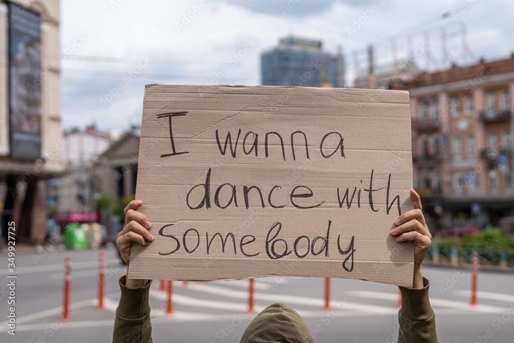

May you dance in union with the Beloved Community
and in joy and peace.

