Contemplative Service for Wednesday,
March 22, 2023

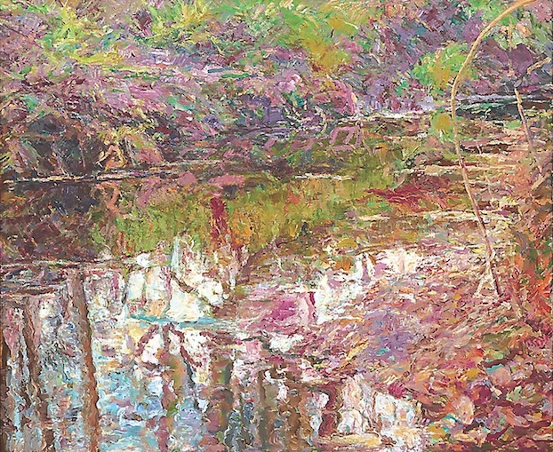
painting by Foad Satterfield

In the end, what kept me going was that I always had a vision … that and choices
— choices and desire create the world.
—Foad Satterfield

First reading: Jeremiah 29:13
You will seek me and find me, when you seek me with all your heart.

Music: “In the Gale,” from The Birdsong Project, by Yo-Yo Ma and Anna Clyne
https://www.youtube.com/watch?v=cEavsIoMxn8

Second reading: from “To Desire Without Object” by Simone Weil
We have to go down to the root of our desires in order to tear the energy from its object. That is where the desires are true in so far as they are energy. It is the object which is unreal. But there is a wrench in the soul at the separation of a desire from its object.
If we go down into ourselves we ﬁnd that we possess exactly what we desire.
We have to go down into ourselves to the abode of the desire which is not imaginary. Hunger: we imagine kinds of food, but the hunger itself is real: we have to fasten on to the hunger.

Music: “Rain Falling From Roof” from Songs of Comfort, by Yo-Yo Ma and Wu Tong
https://www.youtube.com/watch?v=gIXGfMbw1No

Time of Silent Contemplation

To clasp the hands in prayer is the beginning
of an uprising against the disorder of the world…
—Karl Barth

Communal blessing
Holy One,
As the fingertips and toes desire the nourishing heat of the heart, so we desire you. We are fed by a pulse we can barely feel. You are the rhythm at our center and the smallest corpuscle responding. There are days of grief and tiredness, but your rhythm is steadfast, connecting all into the warm union of your desire, of our desire. A living whole. We reach out our hands to feel you tingling within. Amen.

Music: “Tomorrow” from The Birdsong Project, by Hania Rani
https://www.youtube.com/watch?v=Cw3QoLBzq00&list=PLg_1QccIJmbfvZ1RZP6KnncDQC2CmJ_M8&index=5

