Contemplative Service for Wednesday,
March 8, 2023

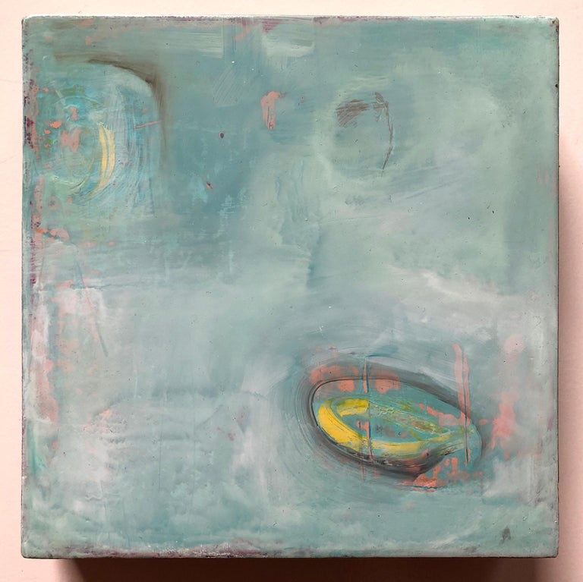
Painting by Michele Mikesell

First reading: John 4:5-15
So he came to a Samaritan city called Sychar, near the plot of ground that Jacob had given to his son Joseph. Jacob’s well was there, and Jesus, tired out by his journey, was sitting by the well. It was about noon.
A Samaritan woman came to draw water, and Jesus said to her, “Give me a drink.” (His disciples had gone to the city to buy food.) The Samaritan woman said to him, “How is it that you, a Jew, ask a drink of me, a woman of Samaria?” (Jews do not share things in common with Samaritans.) Jesus answered her, “If you knew the gift of God, and who it is that is saying to you, ‘Give me a drink,’ you would have asked him, and he would have given you living water.” The woman said to him, “Sir, you have no bucket, and the well is deep. Where do you get that living water? Are you greater than our ancestor Jacob, who gave us the well, and with his sons and his flocks drank from it?” Jesus said to her, “Everyone who drinks of this water will be thirsty again, but those who drink of the water that I will give them will never be thirsty. The water that I will give will become in them a spring of water gushing up to eternal life.” The woman said to him, “Sir, give me this water, so that I may never be thirsty or have to keep coming here to draw water.”

Music: “Von fremden Landern und Menschen” by Robert Schumann, performed by Martha Argerich
https://www.youtube.com/watch?v=T34Wxq0SLNA&list=PLyrS5_ErY3KRrYD_zVmgFjTW7qEsKza4P&index=1

Second reading: “Song of the Brightness of Water” by Pope John Paul II
From this depth—I came only to draw water
in a jug—so long ago, this brightness
still clings to my eyes—the perception I found,
and so much empty space, my own,
reflected in the well.
Yet it is good. I can never take all of you
into me. Stay then as mirror in the well.
Leaves and flowers remain, and each astonished gaze
brings them down
to my eyes transfixed more by light
than by sorrow.

Music: “Bittendes Kind” by Robert Schumann, performed by Martha Argerich
https://www.youtube.com/watch?v=enGvCQh6Yhs&list=PLyrS5_ErY3KRrYD_zVmgFjTW7qEsKza4P&index=4

Time of Silent Contemplation
Of great Love in high thought
I long to think, day and night.
She with her terrible might
so opens my heart.
I must surrender all to her.
—Hadewijch of Brabant, 13th Century

Communal Blessing
Harried and ambivalent, we sit by the well without drinking from it. We let the day’s heat burn us and don’t bathe ourselves in its freshness. Thank you for pausing with us, Holy One. Thank you for using the sinews of your love to pull the heavy bucket from the deep. You raise it to our lips, and you know the distinctness of each thirst. Our dry, chapped souls are soothed and supple in your care. We give thanks.

Music: “Traumerei” by Robert Schuman, performed by Martha Argerich
https://www.youtube.com/watch?v=OippNH2lREU&list=PLyrS5_ErY3KRrYD_zVmgFjTW7qEsKza4P&index=7

May you go forth refreshed and nourished.

