Contemplative Service for Wednesday,
April 10, 2024

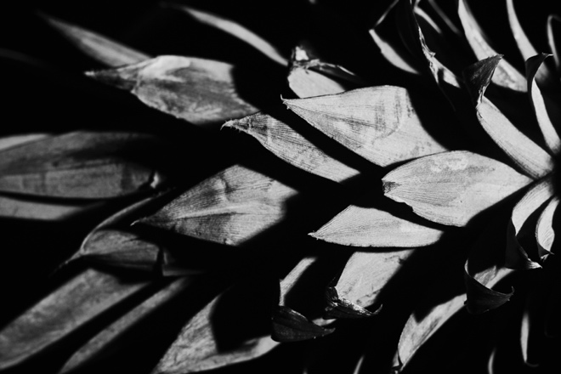
Photograph by Edward Weston

First Reading: from Job 38
Who shut up the sea behind doors
when it burst forth from the womb,
when I made the clouds its garment
and wrapped it in thick darkness,
when I fixed limits for it
and set its doors and bars in place,
when I said, ‘This far you may come and no farther;
here is where your proud waves halt’?
Have you ever given orders to the morning,
or shown the dawn its place,
that it might take the earth by the edges
and shake the wicked out of it?
Have you journeyed to the springs of the sea
or walked in the recesses of the deep?
Have the gates of death been shown to you?
Have you seen the gates of the deepest darkness?
Have you comprehended the vast expanses of the earth?
Tell me, if you know all this.
What is the way to the abode of light?
And where does darkness reside?
Can you take them to their places?

Music: “Unfolding Shapes” performed by Moving Fiona
https://www.youtube.com/watch?v=iZ_ofzcJLfs

Second Reading: “From Heeding Einstein’s Admonition” by Carol Sanford

Einstein gave us what may be the most important caveat for our task of seeking to make the world better, to make the work we do in the world more whole […] He wrote his admonition repeatedly and I found it shows up over a dozen times — with few variations in the message. He clearly knew it was one of his most important capabilities and wanted others to be able to engage in the same way he was imploring us to consider. Here are five examples.
· “To raise new questions, new possibilities, to regard old problems from a new angle, requires creative imagination and marks real advance in science.”
· “No problem can be solved from the same level of consciousness that created it.”
· “We cannot solve our problems with the same thinking we used when we created them.”
· “The world as we have created it is a process of our thinking. It cannot be changed without changing our thinking.”

Music: “Birds” performed by Marea
https://www.youtube.com/watch?v=NDgqkT12gm4

Time of Silent Contemplation

Oh, only for so short a while you
have loaned us to each other,
because we take form in your act of drawing us,
and we take life in your painting us,
and we breathe in your singing us.
But only for so short a while
have you loaned us to each other.
Because even a drawing cut in obsidian fades,
and the green feathers, the crown feathers,
of the Quetzal bird lose their color,
and even the sounds of the waterfall
die out in the dry season.
So, we too, because only for a short while
have you loaned us to each other. —Aztec Indian Prayer

Communal Blessing

One Who Restores and Mends,
We pray into loss and waste, into our wrongheaded technologies and disordered ideals. Please help us to remember that we are plural, not singular. Please give birth so richly within us that we can remember that oldest of truths: that we are not separate from creature, water, fire, air, or soil. Healer, we are not separate from you. Let us live into this wisdom. We pray ourselves past brokenness into your life. Amen.

Music: “The Last Place” by Toru Shimazaki
https://www.youtube.com/watch?v=BuxTSl2cuc4

May you live into the fullness and restoration of peace.

