Contemplative Service for Wednesday,
July 19, 2023

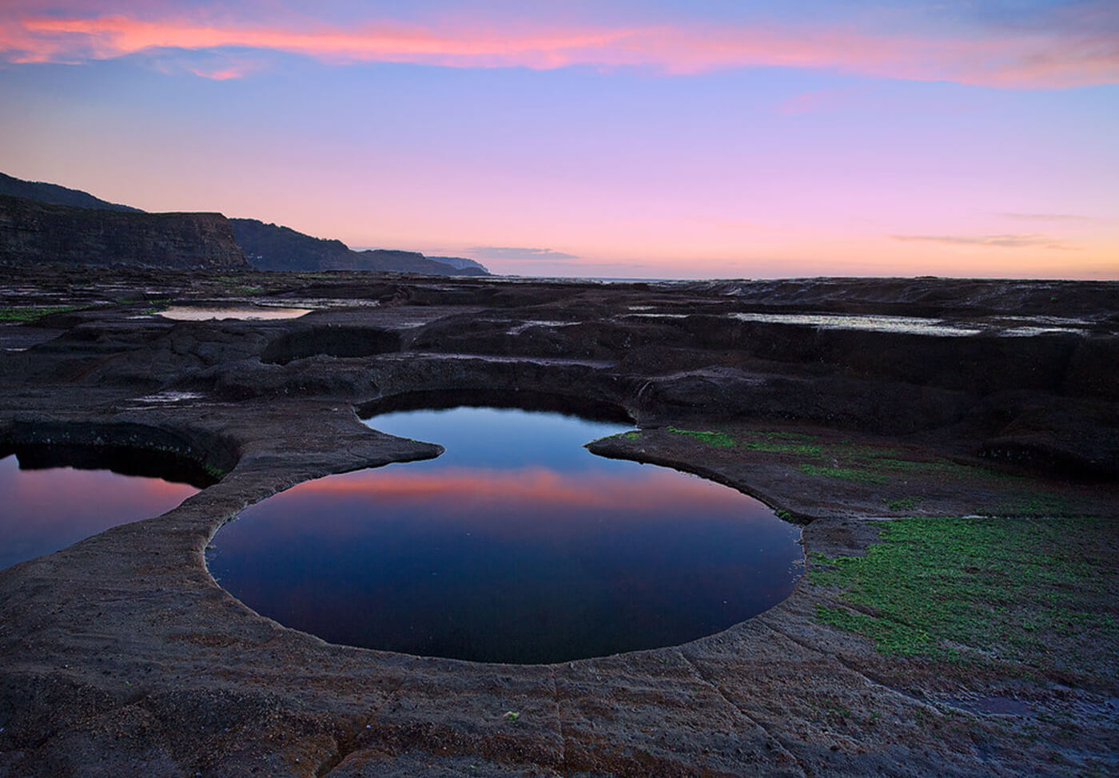

First reading: John 9:1-11

As Jesus walked along, he saw a man blind from birth. His disciples asked him, “Rabbi, who sinned, this man or his parents, that he was born blind?” Jesus answered, “Neither this man nor his parents sinned; he was born blind so that God’s works might be revealed in him. We must work the works of him who sent me while it is day; night is coming, when no one can work. As long as I am in the world, I am the light of the world.” When he had said this, he spat on the ground and made mud with the saliva and spread the mud on the man’s eyes, saying to him, “Go, wash in the pool of Siloam” (which means Sent). Then he went and washed and came back able to see.

The neighbors and those who had seen him before as a beggar began to ask, “Is this not the man who used to sit and beg?” Some were saying, “It is he.” Others were saying, “No, but it is someone like him.” He kept saying, “I am he.” But they kept asking him, “Then how were your eyes opened?” He answered, “The man called Jesus made mud, spread it on my eyes, and said to me, ‘Go to Siloam and wash.’ Then I went and washed and received my sight.”

Music: “By the Still Waters” by Amy Beach, performed by Isata Kanneh-Mason

https://www.youtube.com/watch?v=ZzZ73sCSibM

Second reading: Psalm 107: 35

Here is the Holy One who changes a wilderness into a pool of water
and a dry land into springs of water.

Music: “Wasserklavier” by Luciano Berio

https://www.youtube.com/watch?v=aUANffW3EkQ

Time of Silent Contemplation

Prayer enters the pool of God’s love and widens outward.
—Philip Yancy

Communal Blessing

Now may we swim in you, lapped by your surface.
Now may your depths bring the tides that move us.
Here is your salt and here is your fresh spring; we taste you in all things.
Here is your mist that veils us.
Today we drink you in. Today we float on your blue buoyancy.
Let your current take us where it will. Amen.

Music: “Reflet dans l’eau” by Claude Debussy, performed by Arturo Benedetti

https://www.youtube.com/watch?v=p1PyNHb4BCg

May your spirit be cleansed and refreshed and lifted on sacred currents.

