Contemplative Service for Wednesday,
April 17, 2024

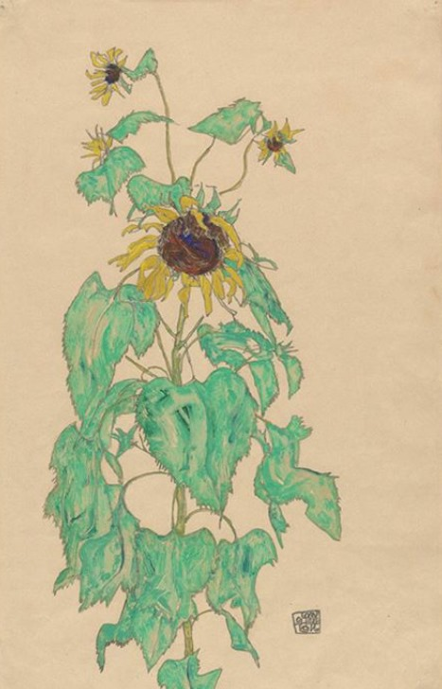
Painting by Egon Schiele

First reading: Deuteronomy 33:14

Month by month, your fruit will ripen in the sunshine.

Music: “Here Comes the Sun” by the Beatles, performed by The Petersens
https://www.youtube.com/watch?v=DF5emO1X0HA

Second reading: by e.e. cummings

I thank You God for most this amazing
day: for the leaping greenly spirits of trees
and a blue true dream of sky; and for everything
which is natural which is infinite which is yes
(I who have died am alive again today,
and this is the sun’s birthday; this is the birth
day of life and of love and wings: and of the gay
great happening illimitably earth)
how should tasting touching hearing seeing
breathing any—lifted from the no
of all nothing—human merely being
doubt unimaginable You?
(now the ears of my ears awake and
now the eyes of my eyes are opened)

Music: “Sesame Street” performed by Joshua Radin
https://www.youtube.com/watch?v=BLj5OusE2h8

Time of Silent Contemplation

let ruin end here

let him find honey
where there was
once slaughter

let him enter the
lion’s cage
& find a field of
lilacs

let this be the
healing
& if not let it be

—danez smith

Communal Blessing

God of Morning, Day, and Night,
We wake in mist and dew, stiff of limb and unfocussed. Slowly, your light warms us and brings us into your embrace. We become supple in your rhythms. We pray to move with you, into you—through awakening into broad daylight. Even the velvet comforts of your night sharpen our awareness of your glow as the moon brings its gravitational massage to the earth. We wax and wane, lunar, in the constancy of your brightness. Amen.

Music: “Good Day Sunshine” by the Beatles
https://www.youtube.com/watch?v=R9ncBUcInTM

May the Holy One make your darkness to be bright.

