Contemplative Service for Wednesday,
May 17, 2023

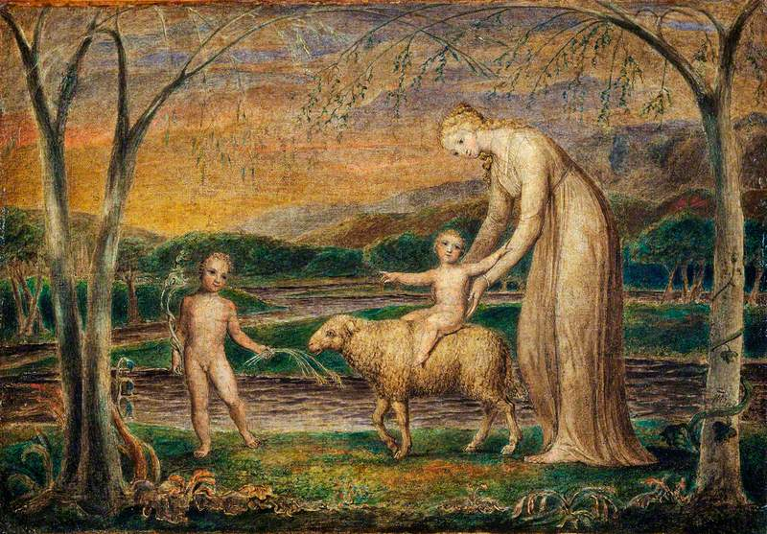

Painting by William Blake

First reading: Romans 16:19

The report of your unity and collaboration has reached to all, and so I am rejoicing over you, for I want you to be wise in what is good and innocent in what is evil.

Music: “In Christ There is No East of West,” performed by Leo Kottke

https://www.youtube.com/watch?v=24CsRD1BMhM

Second reading: “Forever Young” by Bob Dylan
May God bless and keep you always
May your wishes all come true
May you always do for others
And let others do for you
May you build a ladder to the stars
And climb on every rung
May you stay forever young

May you grow up to be righteous
May you grow up to be true
May you always know the truth
And see the light surrounding you
May you always be courageous
Stand upright and be strong
May you stay forever young

May your hands always be busy
May your feet always be swift
May you have a strong foundation
When the winds of changes shift
May your heart always be joyful
May your song always be sung
And may you stay forever young
May you stay forever young

Music: “Accordion Bells” by Leo Kottke

https://www.youtube.com/watch?v=HE0CKC3Jkfw

Time of Silent Contemplation
Today
yes, today
(yes, even today)
may beauty find
may gentleness soften
may care reach
may spirit soothe
may life meet
you and you and you and us
in each broken open space
in each broken open heart
in this broken open world
– Rev. Anna Blaedel

Communal Blessing

Refresh our innocence, Holy Friend. It has not been lost at all, but our innocence does need to be bathed with care and joy. We want this sacred life to be unself-conscious and eager. Show us how to step forward into the waters of your stream and to splash with pleasure. And there you are, with us, when we rise from the current with shining faces and refreshed souls. We thank you in the abandon with which we play. Amen.

Music: Medley: Crow River Waltz/Jesu, Joy Of Man's Desiring/Jack Fig by Leo Kottke

https://www.youtube.com/watch?v=eO10ovIRj2Q

Now may the God of peace sanctify you entirely;
and may your spirit and soul and body be innocent and preserved complete.

***

Come volunteer with us for a work day at The Good Table, an exciting project of The Good Table UCC! They are creating a nursery in collaboration with Planting for Justice which trains and employs formerly incarcerated people. Work days to support this project the last Saturday of each month (May 27) from 12-3. Bring gloves and sturdy shoes and a sun hat—or just arrive around 12 for a tour! Those who can stay will weed, prune, and help prepare the building for renovations.

Address: 5166 Sobrante Ave. in El Sobrante (at the former Adachi Nursery)
Let Elizabeth know if you’d like to arrange for carpooling!

