Contemplative Service for Wednesday,
March 1, 2023

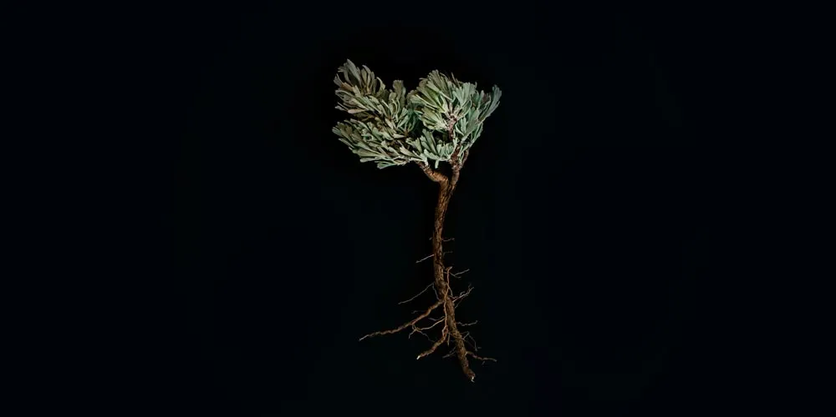

First reading: from Psalm 30

Weeping may remain for a night, but rejoicing comes in the morning.

When I felt secure, I said, "I will never be shaken."
Hear and be merciful to me; O Loving One, be my help."

You turned my wailing into dancing; you removed my sackcloth and clothed me with joy,
that my heart may sing to you and not be silent. O, my own God, I will give you thanks forever.

Music: “Minha Galera” by Manu Chao, performed by Franco Piccinno
https://www.youtube.com/watch?v=u6ewAkk8v9Q

Second reading: “Opera Singer” by Ross Gay

Today my heart is so goddamned fat with grief
that I’ve begun hauling it in a wheelbarrow. No. It’s an anvil
dragging from my neck as I swim
through choppy waters swollen with the putrid corpses of hippos,
which means lurking, somewhere below, is the hungry
snout of a croc waiting to spin me into an oblivion
worse than this run-on simile, which means only to say:
I’m sad. And everyone knows what that means.

And in my sadness I’ll walk to a café,
and not see light in the trees, nor finger the bills in my pocket
as I pass the boarded houses on the block. No,
I will be slogging through the obscure country of my sadness
in all its monotone flourish, and so imagine my surprise
when my self-absorption gets usurped
by the sound of opera streaming from an open window,
and the sun peeks ever-so-slightly from behind his shawl,
and this singing is getting closer, so that I can hear the
delicately rolled r’s like a hummingbird fluttering the tongue
which means a language more beautiful than my own,
and I don’t recognize the song
though I’m jogging toward it and can hear the woman’s
breathing through the record’s imperfections and above me
two bluebirds dive and dart and a rogue mulberry branch
leaning over an abandoned lot drags itself across my face,
staining it purple and looking, now, like a mad warrior of glee
and relief I run down the street, and I forgot to mention
the fifty or so kids running behind me, some in diapers,
some barefoot, all of them winged and waving their pacifiers
and training wheels and nearly trampling me
when in a doorway I see a woman in slippers and a floral housedress
blowing in the warm breeze who is maybe seventy painting the doorway
and friends, it is not too much to say
it was heaven sailing from her mouth and all the fish in the sea
and giraffe saunter and sugar in my tea and the forgotten angles
of love and every name of the unborn and dead
from this abuelita only glancing at me
before turning back to her earnest work of brushstroke and lullaby
and because we all know the tongue’s clumsy thudding
makes of miracles anecdotes let me stop here
and tell you I said thank you.

Music: “Julia” by John Lennon, performed by Franco Piccinno
https://www.youtube.com/watch?v=K5CLgQIXHVI

Time of Silent Contemplation

Blessed are you, loving Creator.
How sweet are your words to the taste,
sweeter than honey in our mouths.
How precious is your faith and leading in our lives,
like a fabric finely woven in our hands.
How marvellous is your imagination for the world,
and your love for every living being is endless.
Our voices shall sing of your promises
and our lips will part to offer witness and thanks.
Blessed be you. Blessed be God for ever.

adapted from the Anglican “Prayer of Thanksgiving”

Communal Blessing

When the pot breaks, we peel back its shards and find a hidden world filled with roots. And, God, it is beautiful. The bare roots beg for a new home, a place to stretch out into richness. The plant’s leafy crest has wilted from its captivity in the pot. So we plant it in moist dark soil. It needed its vessel to be broken so that it could grow. It needed an ending so that it could claim the beginning of fullness. And so we thank you, Holy One, for breaking us open, for showing us the way to a new being, a new home. Amen.

Music: “Blackbird” by Paul McCartney, performed by Franco Piccinno
https://www.youtube.com/watch?v=f_Rm5t9oFpU

Be refreshed. Grow anew. May you find Divine peace through all circumstances.

