Contemplative Service for Wednesday
August 2, 2023

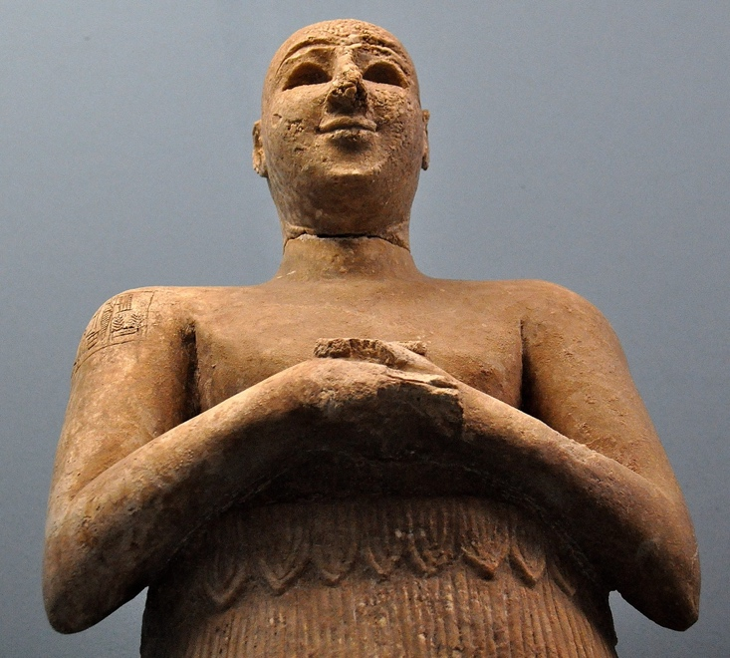

Ancient Sumerian Sculpture of a man in prayer

First reading: from a quote by Meister Eckhart

Some people prefer solitude. They say their peace of mind depends on this. Others say they would be better off in church. If you do well, you do well wherever you are. If you fail, you fail wherever you are. Your surroundings don't matter. God is with you everywhere—in the market place as well as in seclusion or in the church. If you look for nothing but God, nothing or no one can disturb you. God is not distracted by a multitude of things. Nor can we be.

Music: “Alleluia,” a Taize chant
https://www.youtube.com/watch?v=lCdfJQNKnqQ

Second reading: from a talk by James Finley, “Breathing God”
When the Christian mystics read the Gospels, they saw in Christ the exemplar of this unitive consciousness, this spiritual awakening, say analogous to the way the Buddhist tradition understands the Buddha’s enlightenment. They saw Jesus as bodying forth this enlightened, awakened state. What that would mean, specifically, in the Christian tradition would be—well, one way to say it succinctly would be that toward the end of his life, at the Last Supper actually, one of the disciples asked Jesus, “Show us the Father, and that will be enough.” That is, “Let us see God, and we won’t complain.”
Jesus said, “He who sees me sees the Father.” So Jesus bears witness that he realized himself to be the manifestation of the infinite mystery of God. Then Jesus also said, “What you do to the least of my brethren, you do unto me.” That is, identifying himself in realized oneness with God, he simultaneously identified himself with the divinity of all that is lost and broken within ourselves and others. This simultaneous identification of the infinite with brokenness, and expressing that awareness through love, is Christ consciousness, is the mind of Christ.
And so the Christian mystics were people on this meditative path, asking, “How can I habitually ground myself in this Christ consciousness? How can I habitually experience myself to be the generosity of God? And how can I see that generosity of God in all that is lost and broken in myself and others, and respond in love to that?”

Music: “In Our Darkness,” a Taize chant
https://www.youtube.com/watch?v=Y4FM0dbV9ng

In our darkness, there is no darkness, with you, O God.
The deepest night is clear as the day.

Time of Silent Contemplation:
Say I’m sitting in this quietness, in this sincere intention of realizing this oneness-in Christian terms, this is called Christ consciousness-and sitting in this silent vulnerability, these distractions keep coming up, and half-heartedness and all the rest of it…I think what happens is we catch ourselves in the act of perpetuating violence on the part of us that needs to be loved the most. That is, we catch ourselves being punitive toward ourselves in our inability to meditate, as well as we think we should be able to meditate.
If instead we can learn, say in our breathing-a practice I suggest to people is, when you exhale, silently say, “I love you,” as an act of exhaling yourself, as an act of love to the infinite love that’s inhaling itself into you with each inhalation. So on the exhalation, it’s a silent “I love you,” and on the inhalation, you’re listening to the silent “I love you” of God breathing into you the gift of life itself.
As distractions arise within me, so does my reactivity for being so distracted. I catch myself in the act of being punitive toward myself for being so distracted, and what I do is, as I inhale, I inhale this unconditional, infinite love, loving me as unexplainably precious in my powerlessness not to be distracted. Then when I exhale, I give myself, distractions and all, to the love that gives itself to me, distractions and all. As I do that, I’m liberated from the tyranny of distraction into having the power to name who I am, and I discover that love alone has the power to name who I am: I am unexplainably lovable in my powerlessness.
—James Finley

Communal blessing:
Holy One, how do wisdom and your mystery know each other? How does your mystery evolve in our practice of patience and perseverance? We pray that our wisdom
can be practical and kind: wisdom offered to self, to others, to all living things. And in that practical, everyday wisdom—that patient attention—please open us to the surprise of you, to the guiding honesty you offer. Your loving presence never entraps us, but frees us to explore your depths fearlessly. We are alive in this blessing. Amen.

Music: “Alleluia,” a Taize chant
https://www.youtube.com/results?search_query=Taize%2C+allelua

May wisdom bring you peace and balance.

