Contemplative Service for Wednesday,
December 20, 2023
Fourth Week of Advent: Love

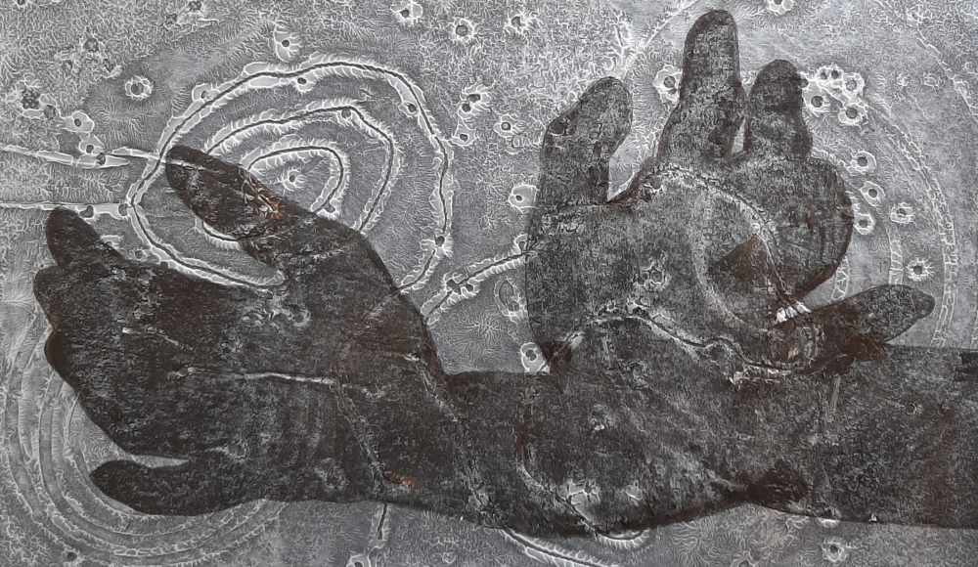

“Compassion” by Robert Williams

First reading: 1 Corinthians 14: 16

Let all that you do be done in love.

Music: “Awakening the Heart of Compassion” by Brother Phap Linh
https://www.youtube.com/watch?v=YarhXTDs8Z4

Second reading: from Hadewjich of Antwerp, 13th Century

The madness of love
Is a blessed fate;
And if we understood this
We would seek no other:
It brings into unity
What was divided,
And this is the truth:
Bitterness it makes sweet,
It makes the stranger a neighbor,
And what was lowly it raises on high.

Music: “Sacred Love” by Sviridov, performed by Intrada Moscow
https://www.youtube.com/watch?v=V9bWVnNon4g

Time of Silent Contemplation

Dear God, please reveal to us
your sublime beauty
that is everywhere, everywhere, everywhere
so that we will never again
feel frightened.
My divine love, my love,
Please let us touch
your face.
- St. Francis of Assisi

Communal Blessing

Loving One, we pray that your love will show us Love itself, as perfection. And further, that perfection is not static or completed, but full and responsive.
Yours is the love that elicits more love.
Yours is the love that makes our limited, self-interested love radiate beyond its own error and self-interest.
We do not yet know how fully love has dawned in our lives. It will take a birth, but not just the birth of a disenfranchised baby in a rural stable. Love’s living ardor will be born through us, with us, for us over and over. Amen.

Music: “Fall Fearless Into Love” by Darlene Franz
https://www.youtube.com/watch?v=V9bWVnNon4g

A gift of love to you.
May you be warmed and animated in Love’s fire.

