Contemplative Service for Wednesday
May 31, 2023

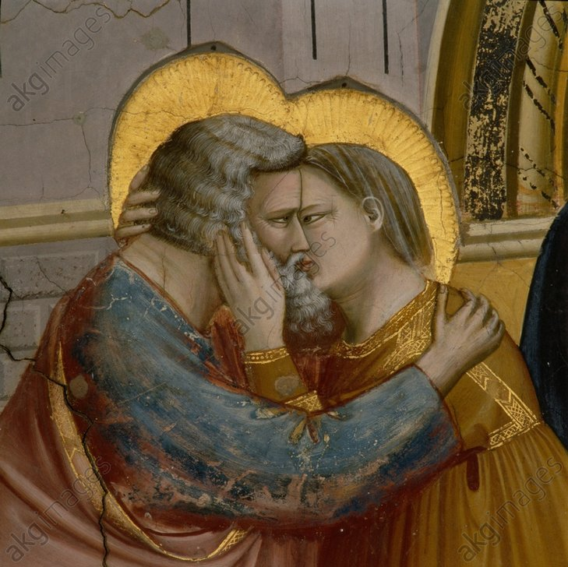

from a detail of a painting by Giotto

First reading: Luke 6:21
Blessed are you who hunger now, for you shall be satisfied. Blessed are you who weep now, for you shall laugh.

Music: “Wild Sweet,” performed by Starling Arrow

https://www.youtube.com/watch?v=-al77IYpmsg

Second reading: by A.H. Almaas and Karen Johnson

Any spiritual work involves the element of love, whether explicitly or implicitly. What we want to explore is how the energy and quality of love explicitly open the door to reality and to our deeper nature. The portal is there for every human being to open; each of us can be fully real and alive in all our interactions. And desire, as it is felt and experienced, even in the body, is a part of that openness, whether it becomes sexual or not. For many reasons, eros has become separated from the pure and the holy, and as a result, it is usually relegated to the domain of the gross and unrefined. But desire is the energy of the divine. As such, it is always divine and pure.

Music: “Ksenitia tou Erota,” by Giorgos Kalogirou, performed by Amalgamation Choir
https://www.youtube.com/watch?v=dm1MWr0ZNdI

Time of Silent Contemplation

The most potent and acceptable prayer is the prayer that leaves the best effects. I don’t mean it must immediately fill the soul with desire…The best effects are those that are followed up by actions—when the soul not only desires God, but strives for God’s honor and fullness.
—Teresa of Avila

Communal Blessing
You come with risks, Holy One. Love is the ultimate challenge—to fill ourselves with your presence. May we be fertile with risk, with opening. In love, we risk wholeness, and for wholeness, we need you as haven. May our desire finally make us full and safe and alive as you intend. May our desire so rise within us that all danger for ourselves or others is washed away. May our desire be fulfilled in you. Amen.

Music: “The Ecstasy of Gold,” by Ennio Morricone, performed by Carolina Eyck
https://www.youtube.com/watch?v=ajM4vYCZMZk

Peace be with you.

