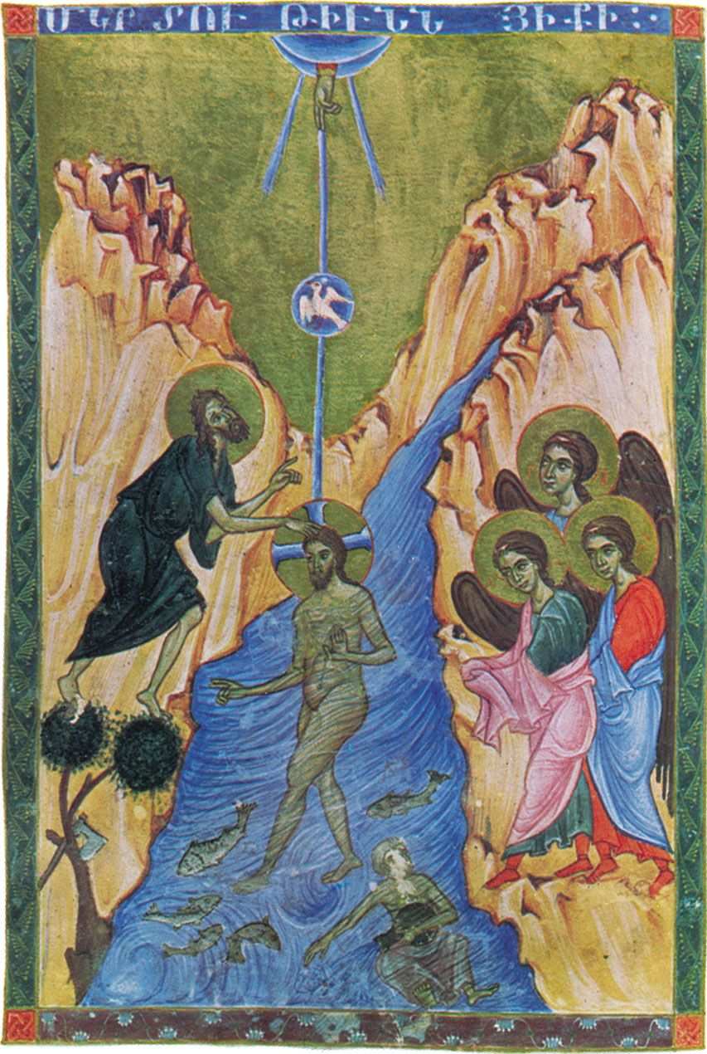
13th Century miniature from Topkapi Palace, Istanbul

I wanted to jump into Pride Month this week and, especially, welcome our guest speaker for Second Hour, Sie Savage Chambers. It was a meaningful Sunday, and I am so appreciative of all who shared from their experiences.

What I didn’t do was note that Sunday was Trinity Sunday. Trinity Sunday is meant to be a joyful holiday in the church, but I think we often don’t think about the Trinity, much less Trinity Sunday as a holiday. My pondering started off with some reflection on the power of the number 3. Did you know:

The ancient Greek philosopher, Pythagoras, postulated that the meaning behind numbers was deeply significant. In the eyes of ancient thinkers, the number 3 was considered the perfect number, the number of harmony, wisdom and understanding. It was also the number of time – past, present, future; birth, life, death; beginning, middle, end – it was the number of the divine. In contemporary studies, three has been shown to be a good marketing number. Consumers will be convinced of a product’s worth if it is described with three qualities; add a fourth and they become skeptical. We have three branches of our government: legislative, executive, and judicial. Three branches so that they can serve (we hope) as checks and balances on each other.

So is our Holy Trinity set up as a series of checks and balances? No. I see the Trinity as expressing the many ways that God meets us—as creator, as incarnated human guide, as suffusing presence. This is pictured above in the image of a divine hand extending downward, a dove, and Jesus on this earthly plane. Trinity Sunday reminds us that we don’t have to go to God, straining ourselves to accommodate to God’s ways, but that God will always find us, appearing in ways that we can understand.

In our threefold God, perhaps we can find the rhythm of the divine, the lilt of the waltz and its three beats. And, if you will excuse a little levity, I offer this version of Strauss’s “The Blue Danube” which conveys the rhythm in a quite distinct way (because, after all, God is present with us in humor as much as in seriousness).

https://www.youtube.com/watch?v=O3HW67QzTpU

In faith,

Elizabeth

