Reflection for Holy Week
Monday, March 25, 2024
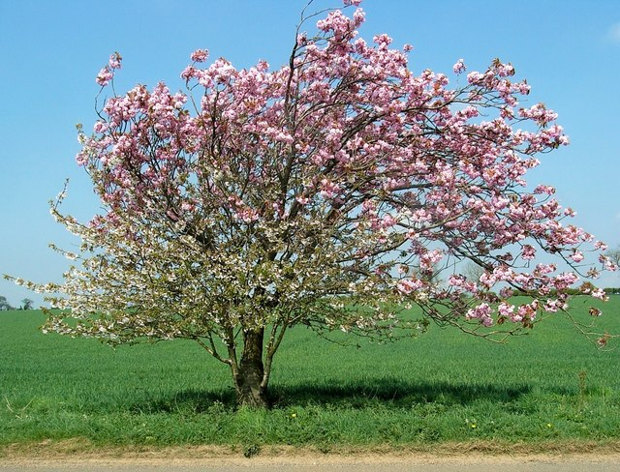

All the apple trees came out in blossom Good Friday. It rained and got colder, but today is very bright with a pure sky. The willow is full of green. Things are all in bud.
And in my heart, the deepest peace, Christ’s clarity, lucid and quiet and ever-present as eternity. On these big feasts you come out on top of a plateau in the spiritual life to get a new view of everything. Especially Easter. Easter is like what it will be entering eternity when you suddenly, peacefully, clearly recognize all your mistakes as well as all that you did well: everything falls into place.
—Thomas Merton

We do, sometimes, talk in various church groups about what a sorry state the world is in, and it is tempting to give way to a sense of pessimism. But the very fact that we are together and thinking and sharing and supporting each other points to a reality that we can’t quite grasp but which is there nonetheless. There is something larger opening within creation even at the bleakest times.

I think of Holy Week as a whole—Palm Sunday, Maundy Thursday, Good Friday, and, finally, Easter. That means we are walking through a labyrinth of events—for example, as followers of Jesus, we are among the disciples who betrayed Jesus, who couldn’t stay awake in the Garden of Gesthemani, who fled the crucifixion in terror and despair.

And still, we remain so beloved by Jesus.

Moving through the whole of Holy Week, we get led each year into tight spots and darkness that threaten to extinguish us. At the moment of grief and lost hope, there is the unexpected opening. The opening of the tomb. The opening of our hearts. The opening of life itself.

Like Thomas Merton, we can embrace the profound peace and clarity of this miracle. And the blossoming trees remind us that Easter is just the beginning. Before long we will, like the trees, be ripening and bearing fruit.

In faith,
Elizabeth

Announcements

Please join us at 7 p.m. on Friday for a Good Friday service offered in collaboration with eight local U.C.C. churches. Our theme is “Our Lives Connected: The Cross as Solidarity.”
We hope you will come for this deeply meaningful time of reflection and faith.

Our Easter Offering will go to the Black Wealth Builders Fund and will assist Black families in putting together the necessary funds to create a down payment on the purchase of a house. We are seeking to meet a matching grant of 10K, and we already have a single generous donation of 1K! Please give generously to this reparative and justice-building project that will benefit people in our community.

