Reflection for Monday, April 8, 2024

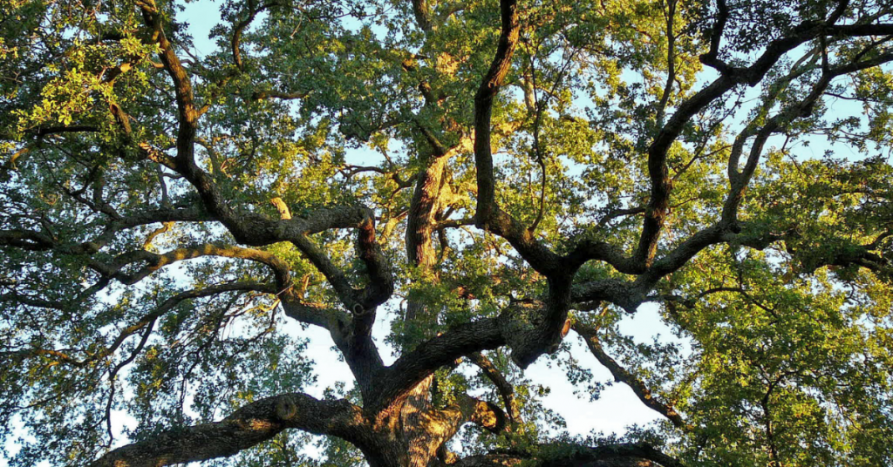

A friend of mine in Colorado once came back to Denver from a trip and, looking around, said, “We’re so tree-starved in Colorado.” You might not think it, but much of Colorado is not mountain or forest—even Boulder, right at the foot of the Rockies, is a semi-arid plain.

So Randy and I were ecstatic to be reunited with an environment rich with trees when we came to California. In the yard of our Oakland rental, we planted an olive tree, a pomegranate, and two Japanese maples. One day Randy came home with three plants. “What are those?” I asked. Randy looked sheepish. “Three trees.” Not only were they trees, they would grow to be enormous: oak, cedar, and some kind of evergreen.

When we moved to Pinole, we transplanted the pomegranate and one of the Japanese maples—and brought along the three saplings. Then my son Wilson gave me a fig tree which joined the persimmon, lemon, and calamansi among the fruit trees and a mature Japanese maple in the backyard. One day Randy and I went to a nursery to buy a few plants for the garden, and there was a weeping beech tree that cried out to become part of our household.

What pleasure to look at the texture and shape of leaves and to see creatures using our trees for food and shelter! As spring arrives and we approach Earth Day, let’s hold our concern for the environment in the embrace of how much we love our planet. I believe we will be much better activists if we are attuned to the joy of the natural world.

I finally told Randy that we had to plant the saplings that have been sitting in pots for two years. He recently opened our back gate to Pinole Creek Path and planted them along the pathway. As Randy was working, a child pedaled slowly past on his trike. “Look, Daddy,” he said to his father, “that man is planting a tree.” “Yes,” his father nodded, “We really like trees.”

In faith,

Elizabeth

Announcements:

You are invited to attend a celebration of the life of John Thursby on Saturday, April 13, at 11:00 a.m. with reception to follow. You may also join us via livestream here: XXXXXX

**

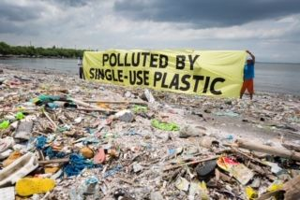

Special Speaker on Plastic!

During worship on April 14th, OCC will welcome a guest preacher, Rev. Pam Abbey, a retired Methodist Minister who is a member of Walnut Creek United Methodist Church. Kathi Kling and Nancy Thursby heard Rev. Abbey preach on plastic at the Methodist Church when they were there to play in the Methodist Handbell Choir. They found her message so valuable and so appropriate for our Earth Day of observance of plastic pollution that they thought it would be a good idea to invite Rev. Abbey to deliver her sermon at OCC and she accepted! Please make every effort to attend this service.

**

Many thanks to Karen Sanford for sharing her spiritual journey on Sunday. It is a wonderful gift to learn about the lives and faith journeys of people in our community.

**
Our fundraising for the Black Wealth Builders Fund has yielded more than 6K! And it is not too late to add your contribution to this important project. We have a goal of 10K which will be doubled by a matching gift. If you would like to participate, mark “Black Wealth Builders” in the memo of your check.

