Reflection for Monday, March 13, 2023
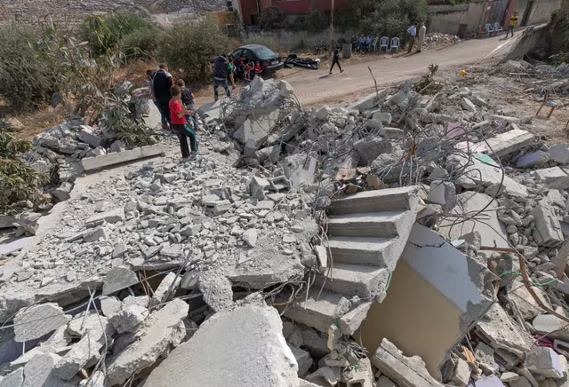
photo from AP News Service

As our journey through Lent continues, I am finding so many ways to think about this concept of “home.” Many of our spiritual forebears were sojourners, seekers, and without a stable home. But it is one thing to relinquish home for a quest or spiritual journey, and wholly another thing to be deprived of home by natural disaster, war, or occupation. The earth’s population is now crying out with displaced people. How can we think of home when so many do not have a safe place to stay? How can we, as people of faith, advocate for justice and the right of every person to shelter—and, just as importantly, to home with all its cultural richness, its sense of kin and community?
Many people in our congregation have been active in support of our Palestinian brothers and sisters, especially through Jewish Voices for Peace. It’s important, amid a world in turmoil, that we continue to pay attention to what is happening in Palestine. The current trend of home demolitions is tragic. Today, I am grateful to share three poems by poet Michal Rubin, an Israeli who lives in South Carolina. Michal advocates passionately for justice for Palestinians and has been recording Israel’s demolition of Palestinian homes in a poetry manuscript entitled Break Down. I hope you connect with these works of witness.

In faith,
Elizabeth

Demolition
Breakdown—Fifty-two weeks—-Number of demolished structures: 957; number of girls who lost their homes: 235; number of women who were displaced: 258; number of boys who became homeless: 276; number of men whose houses were bulldozed: 288;
Grooved arid soil lay beneath the rubble holding silent displaced screams
echoes of wrecking shroud a wilted soldier’s soul boredom masks brokenness
gray rubble gray dust gray hair gray tears gray sunray rest on torn red drape
number of affected people due to demolished structures: 28,474; number of red torn curtains: ~2,015; number of clothes-filled bundles; ~ maybe 3,000; number of keys without doors: estimated 3,525; number of concrete heaps: 957.
I write my red screams over crumbled soul of boy- soldier lost and gray
and dream of him bent torn red curtain receives his awoken brokenness

There Here
The soccer ball rolled The blanket is dragged
behind the pile on the concrete,
awaiting the muffled underground
footsteps chasing it it has a smell, she notices,
grabbing its dusted skin learning to fall asleep
leftover from the rubble with bombs
onto which it rolled in the background

In Gaza

tomorrow’s touch
through the settling dust

will remind you of
love

unhidden in the rubble
behind the corner

forbidden moment
fused with desert breeze

salted droplets we carried
home

or what was home

Coming in April!

Interfaith Power & Light Faith Climate Action Week April 14—23, 2023
Theme: Living the Golden Rule: Just Transition to a Clean Energy Economy

From the Interfaith Power and Light Guide:

We have the “responsibility as people of faith and conscience to transition to energy sources that safeguard our common home and look at ways to respond to this challenge with just solutions for all.”

“We all want to live in a community of mutual respect, where everyone abides by the Golden Rule: treating others the way we want to be treated. We all want to have meaningful work that sustains our families and communities and to live in a clean and healthy environment.

We are already transitioning away from fossil fuels to a clean energy economy, and as people of faith and conscience we can ensure the transition is made with justice. We can have both a healthy economy and a clean environment, and the process for achieving this vision can be fair and not cost workers or community residents their health, environment, jobs, or economic assets. Working for a just transition is a faithful response to the call to care for our neighbor and the interconnected community of all life.”

