Reflection for Monday,
October 23, 2023

Olive branch by Michael Aram

What I am asking is for us to dare to hold the humanity, the heartache, and the need for security of the Jewish people while also holding the humanity, the dignity, the need for justice of the Palestinian people. For too long, these two have been set up as a false binary. In fact, the only liberation will be a shared liberation. The only justice is a justice for all.
—Rabbi Sharon Brous, of Congregation Ikar in Los Angeles

As we struggle with how to respond to the conflict and tragedy in Israel and Palestine, here is the statement from the United Church of Christ on the situation and how we can help:
https://support.ucc.org/middleeast?inf_contact_key=8a7626fa92deb93cf6e2965051552347cc0558ed5d4c28cbfab114022b1ec50d

We are deeply grateful to Luciano Kovacs (and to Kerry Poethig, who made the connection and arrangements) for coming to give us important historical context on the Middle East and ways we can respond. He supplied us with this film, for those who are interested in learning more about the situation in Palestine:

https://www.presbyterianmission.org/story/we-refuse-to-be-enemies/

For those who would like to contact their elected officials urging them to work and legislate for a ceasefire, this is an extremely easy way to do so:

https://action.cair.com/a/gazaunderattack

In solidarity with all who have suffered violence and loss of life in the past weeks, I am grateful that we can offer the laments below by Lee Cruise and Katrina Staten.

In faith,

Elizabeth

~~

I

I believe different things in different places.
I trust the hand that touches me in kindness.
I wonder where and when.
I hope that the dead owl’s spirit heals me.
I love the first light which says hello and welcomes me.
I love the last light which covers me with a gentle hug.
I thank the heart that feels my loss.
I listen for the sounds of peace.

—Lee Cruise

PLACE KATRINA’S PIECE HERE

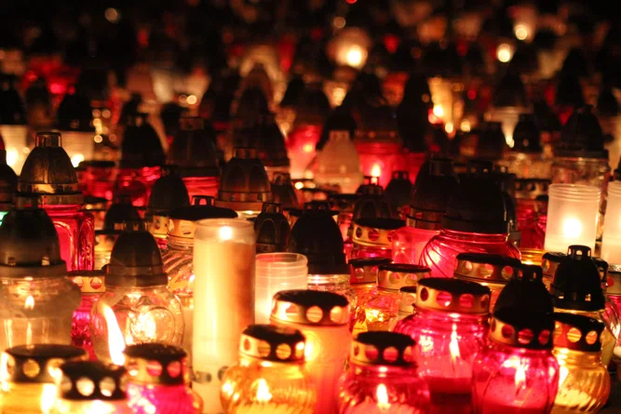

Sunday, October 29 we will celebrate our annual All Saints Day Sunday. We will have a tables with flowers and candles toward the front of the church. You are invited to bring photos and messages for your beloved people who have passed on. We will bless them with prayer and remembrance.

