Reflection for Monday, November 13, 2023

It’s hard to remember the joys of vacation until you are in their midst. Here’s what I’ve been enjoying this week:

--Letting our crochety dog wander off leash in a secret place we know north of Mendocino
--Having the rain pour down while we stayed inside and read
--Wandering along the coast just north of Point Cabrillo Lighthouse.

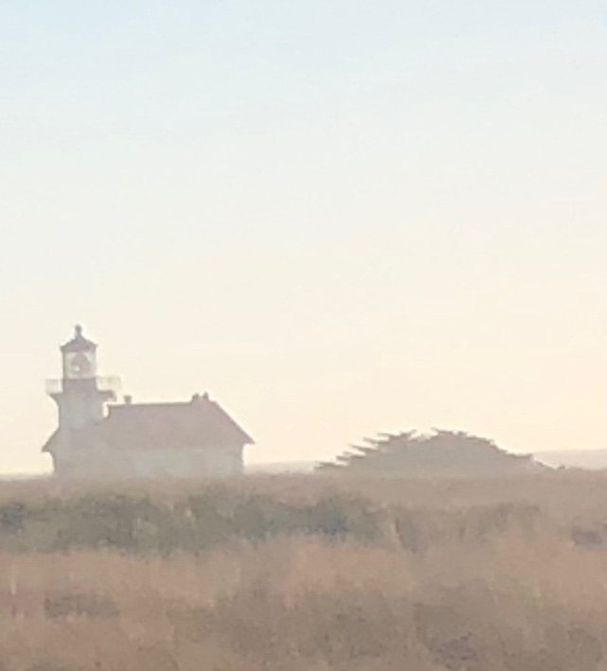

--Writing poems and an essay instead of a sermon!
--Watching Randy’s list of birds he’s sighted get longer and longer
(His favorite so far is the fox sparrow)
--Finding my favorite junk shop in Fort Bragg closed because of Veteran’s Day and being able to shrug: I can just come back another day.
--Taking pictures of the assorted and colorful mushrooms I find on my hikes

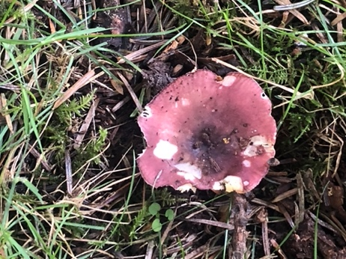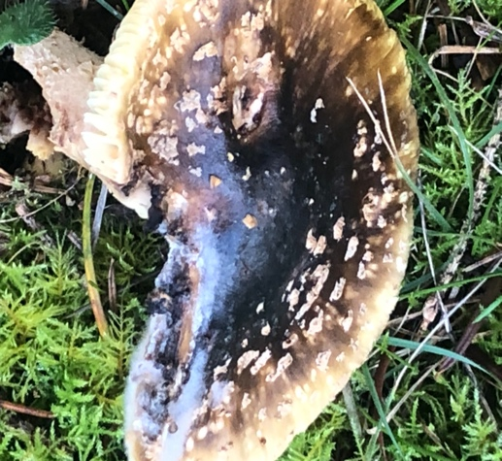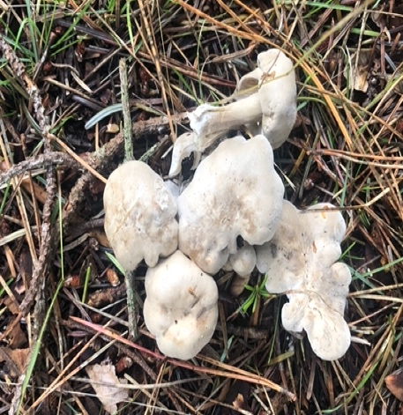

--Obsessively working on a jigsaw puzzle
--Watching the sun set over the ocean from the bedroom window of the house we are renting

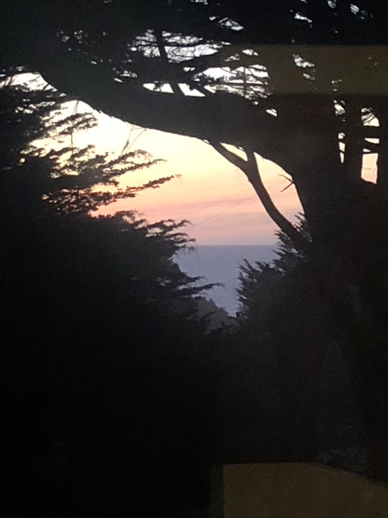

Sending all of you greetings and gratitude from Mendocino. I wish you daily joys wherever you are.

In faith,
Elizabeth

