Reflection for Monday,
February 20, 2023

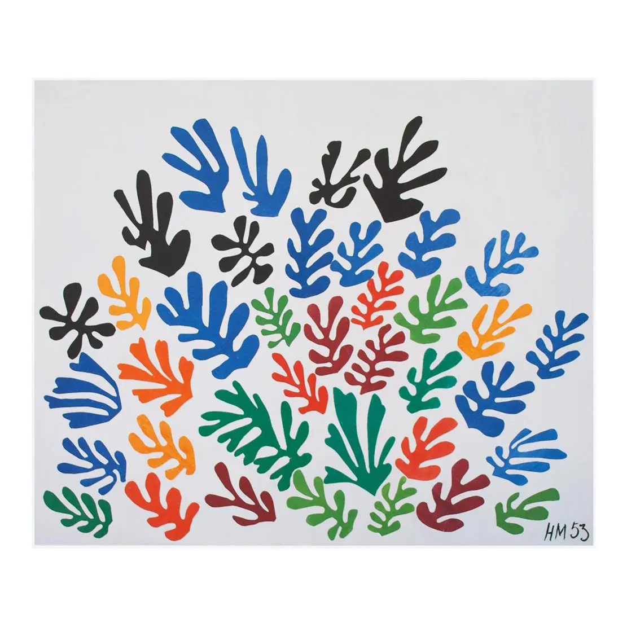
Artwork by Henri Matisse

Hello Beloved Community,

There’s a lot going on at the church these days, and I’m happy about that.

First, I want to share a link with you for “Stranger at the Gate,” the film I referenced in my sermon today. It’s only 30 minutes long and well worth your attention. (And you can watch it for free!). https://vimeo.com/772595268 This story about Richard McKinney and his experience with the Muncie, Indiana Islamic Center—and how the kind people there changed his life.

Next I want to remind you that this week is the beginning of Lent. (Hello to Bill Abriel who is in New Orleans getting ready to celebrate Mardi Gras!) On Wednesday at 10 a.m we will hold an Ash Wednesday service in the chapel. This short service will include readings and music. If you would like to receive ashes, you will also be able to do that.

Looking ahead, we are preparing for a rich Holy Week and Easter. During Holy Week this year, we are blessed to have Sarah Elovich (some of you have already met her) leading a Seder dinner for us on the first night of Passover, April 5. Our plan is to meet in the Fellowship Hall from 5-8 for a meal and for the Seder ritual. However, we need to make plans for food and attendance. Currently we are estimating that the dinner will cost $36 per person, but no one will be turned away for lack of funds! Look for a sign up sheet at church next Sunday, or rsvp to Anna at orindachurch@gmail.com

Finally, I’d like to follow up on our moderator Anne Barr’s comments during our time of announcements. I am a little incredulous that next year I’ll be heading into my fifth year at the church. With that in mind, we have been thinking about sabbatical time. What would be renewing for me? What would be refreshing and meaningful for the church? I am applying for a Lilly Endowment Grant for clergy renewal and we would like members of the congregation to have an opportunity to offer their feelings and suggestions as we plan for this. Expect to see some opportunities for Zoom conversation in the coming days. Your insights and ideas are valuable.

In faith,

Elizabeth

