Reflection for Monday,
February 26, 2024

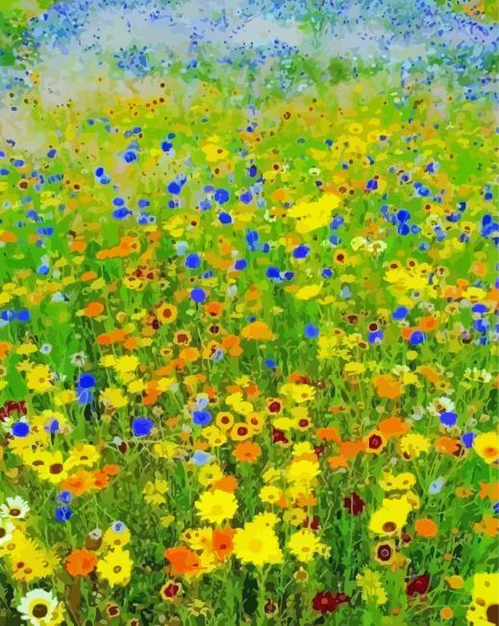
Painting by Gustav Klimt

This Lent, we have been discussing the season as a time to open to God and release our usual preoccupations and desires. The writers’ group has had some valuable conversations about the various nuances of words like “surrender” or “letting go.” We are grateful today to have an insightful reflection by Janet Schwartz. May her thoughts enrich your Lenten journey.

I think about those terms, “surrender” and “letting go”. I like to
practice “turning it over” instead.

Surrender sounds like a helpless word for some reason…like the tragedy
or problem is too great, too ominous, for human reasoning.
And “letting go” sounds frivolous like suddenly letting go of a balloon.
It sounds like one is ignoring the problem.

However, “turning it over” means “Here it is, Lord…please help.” Personally,
I like thinking of asking our benevolent God for help.
I see God as an all-knowing presence with the strength of mountains who
can assist all of us.

If we are supposed to have dialogue between ourselves and God, it must
be give and take…sharing the help, sharing the burden, finding the
answers. If there is a personal God there is a sharing of the good, the bad,
and the ugly. There is a supreme strength that emboldens us mortals and
pushes us forward to success.

Making decisions is an arduous task. Such a relief to have a personal
advisor to lean on, now and forever.

Janet Schwartz
Lent 2024

Peace Vigil

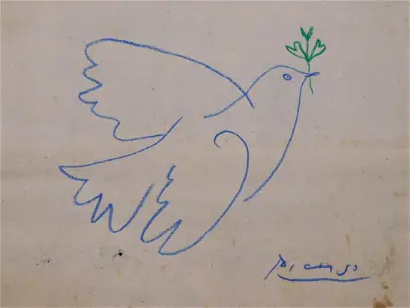

As we journey through Lent, you are invited to join us for our Peace Vigil.
In faith, we pray—and insist!—that peace is possible.

Each Sunday at 9:30 a.m. in the narthex, we will have a brief prayer and communion service, that God may break open our hearts and guide us into the great work of peace.

Each Thursday at 10:00 a.m. in the church library, we are meeting for contemplative creative action. Inspired by the Birds of Gaza project (https://www.birdsofgaza.com/) in which people of all ages handcraft birds to commemorate the lost lives of Gazan children, we are making birds to honor the precious lives of all humans, to uphold God’s love for each living being, and to make a witness for peace.

Already, you will see birds in the narthex and sanctuary, some made on maps to affirm that God’s love is global and to recognize the suffering caused by violence and war in so many places on our planet.

May peace grow and flourish for all people and in all places.

**

Please join us next Sunday, March 3, for a Second Hour presentation and discussion with Rev. Barry Cammer who will join us to discuss the Black Wealth Builders Fund and let us know how we can support this invaluable project.

