Reflection for Monday, April 3, 2023

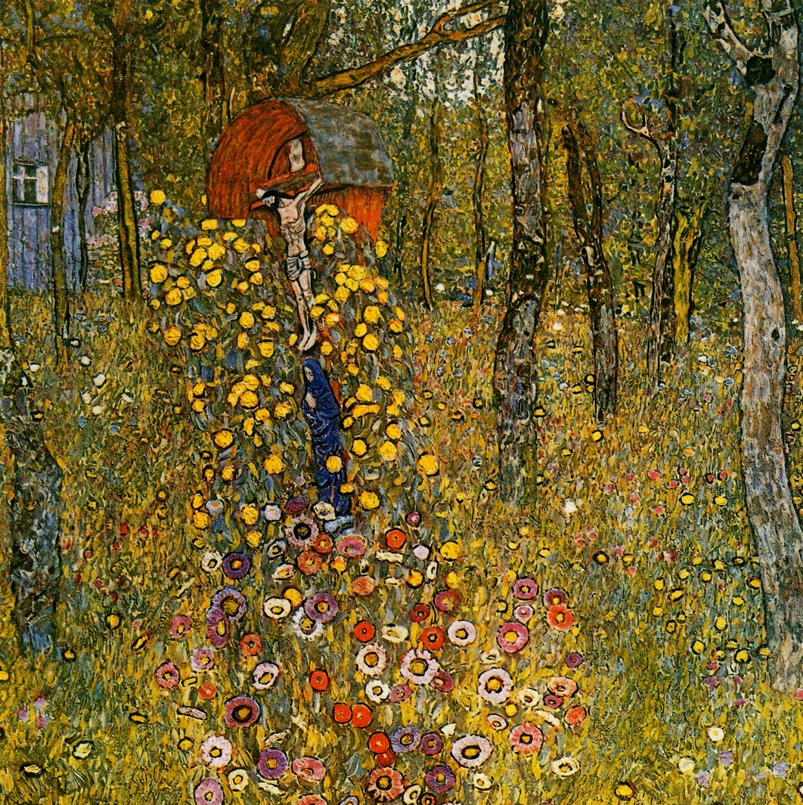
painting by Gustav Klimt

Holy Week

When I was a child, I remember hearing a minister say that Easter is the highpoint of the Christian year. This confused me. Wasn’t Christmas really the most important holiday?

Christmas is an unambiguous good: a birth, a light shining in the darkness—plus all the meals, parties, presents!

Easter, though, is complicated goodness. The horror of the crucifixion, the betrayal by Jesus’s disciples, and then this the question of what resurrection really is and could mean for us.

What if we invite our joy to embrace the complications? On Wednesday night this week, some of us will be participating in a Seder. Sarah Elovich, who will be leading the evening, reminded me that Passover is a celebration of liberation. So let us remember throughout the week that God intention is to liberate us.

On Friday, I invite you to join us for a 7 p.m. Good Friday service. The most sober service of the year, we mourn the death of Jesus and the ways even his most devoted followers let him down. Yet in this mournful moment, we are joined by five other congregations—their ministers, musicians, and even our dancers. In the darkest moment of the Christian year, we come together in faith and unity.

And then, on Sunday: Easter! Jesus is returned to us, offering new life to all. Our faith and hope, our unity and liberation, all renewed in God’s love which accompanied us, after all, the entire way. And so we begin anew our journey seeking, and finding God through our sometimes complicated, but always rich, joy.

I look forward to continuing on the journey with you.

In faith,
Elizabeth

Easter Offering

This year our Easter offering will support the Black Wealth Builders Fund. For more details about this fund, please read on. Many UCC congregations in the Bay Area are committing to this important fund and we hope OCC members will give generously.
What is the Black Wealth Builders Fund?
The Black Wealth Builders (BWB) Fund is a reparations project launched by Arlington Community Church (UCC) in 2021. The fund is designed to help repair a small portion of the financial damage of racism and white supremacist policies—in particular, the longstanding barriers to Black homeownership that have existed in our East Bay communities.

CURRENT AMOUNT RAISED: $332,840
Why choose Black homeownership as a reparations project?
For most Americans, a home is their major source of wealth. A home appreciates over time and can be passed down to the next generation. But because of segregation, redlining, adverse (or nonexistent) mortgage terms, and loan application rejection, the Black community has been shut out from this major wealth-building tool.According to the U.S. Census Bureau, the rate of Black homeownership is 44 percent, the lowest of all groups. In contrast, 74 percent of white families in the U.S. own a home.
Addressing Black homeownership is a way to make long-lasting, systemic change in how Black communities can build wealth and pass it along to their heirs.

How does the fund assist potential Black homeowners?
A major barrier to homeownership, especially in the high-priced Bay Area, is lack of a down payment. This is especially true for Black homebuyers, who may have good incomes but no access to the additional capital they need for a down payment. The BWB fund:
• Creates a zero-percent-interest loan fund, to be paid back only when the home is refinanced or sold;
• Works through local organizations to identify potential Black homebuyers who are on the journey to home ownership but who lack a down payment.
Because the BWB is a loan fund, money from home refinance or sale flows back into the fund, ready to assist other homebuyers. In addition, there may be other avenues by which we can support Black homeownership through our fund.
How many Black homebuyers has the fund assisted?
Since making our first loan in May 2022, we have made a total of 14 loans, assisting 21 first-time Black homebuyers, for a total of $275,000 provided throughout Contra Costa and Alameda counties.

